Quiz Management User Manual

Opening with console:

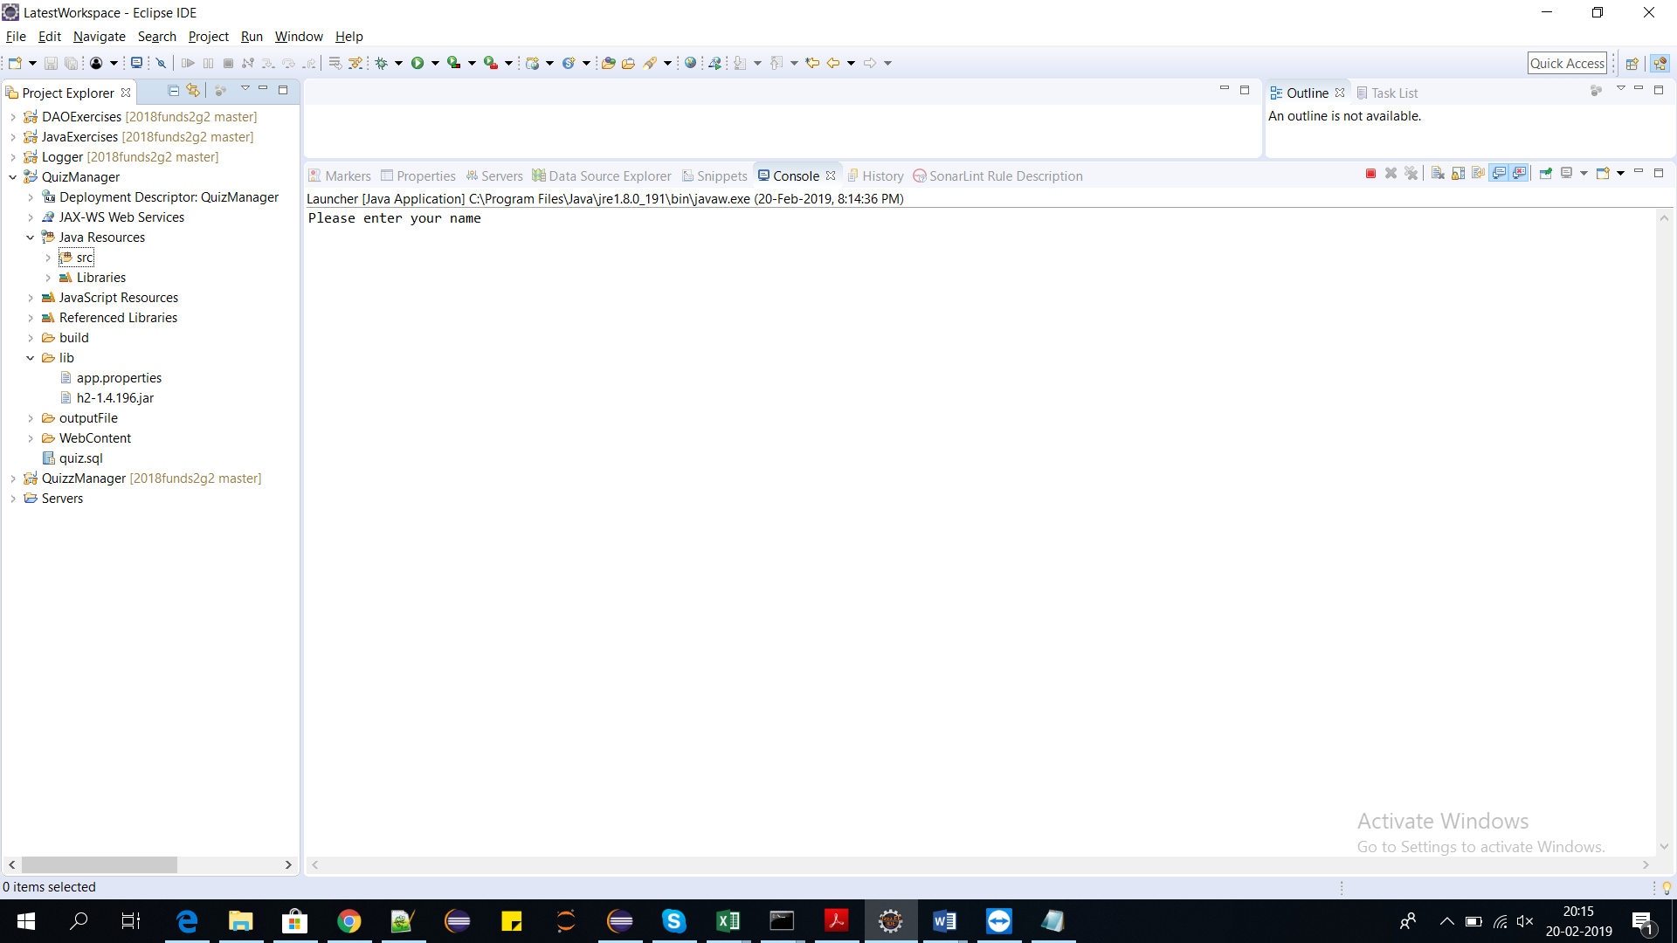

Here the user has to enter the name.

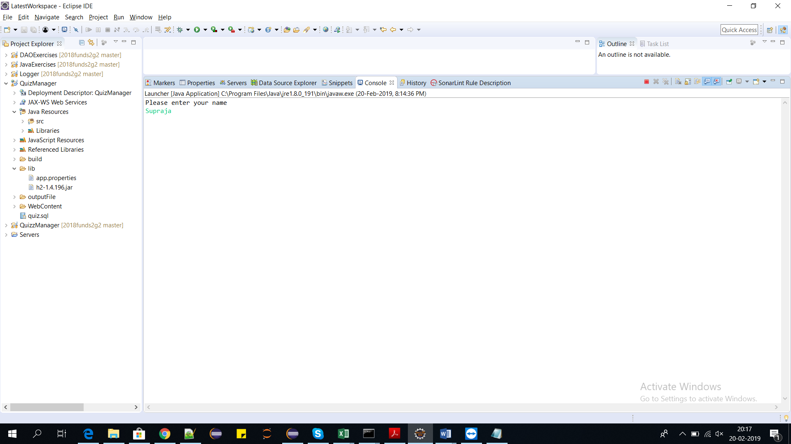

Now press enter, the user can see the name he entered.

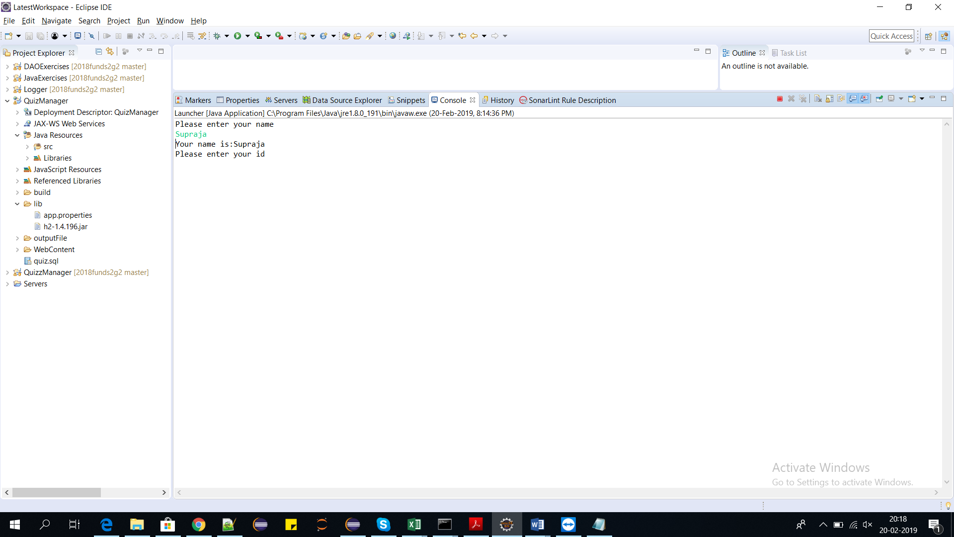

Now the user has to enter the id.

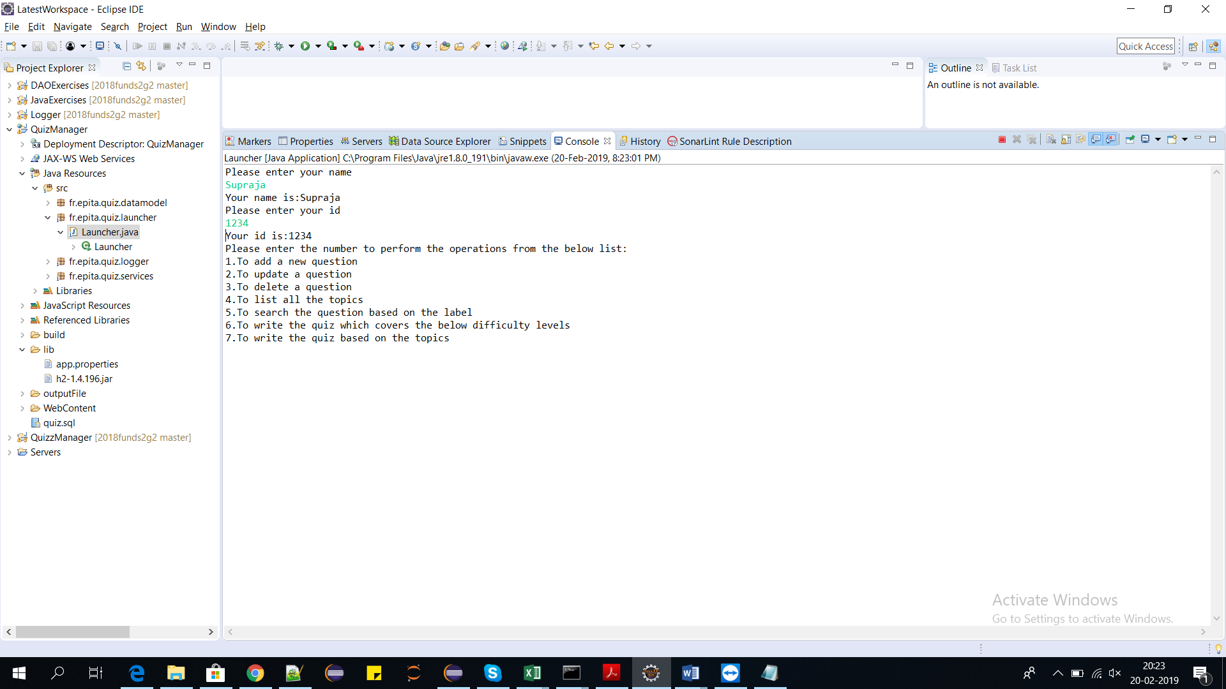

Now the user has to the choose a number to perform the corresponding operation.

**To create a new question:**

1. 1)To create a question the user has to select 1 to insert MCQ question.

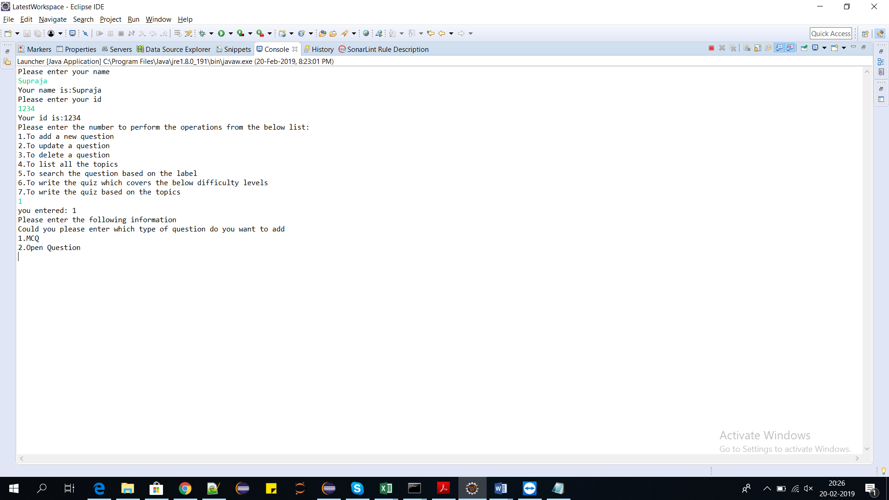

2)The user has to choose one of the options. If the user chooses 1

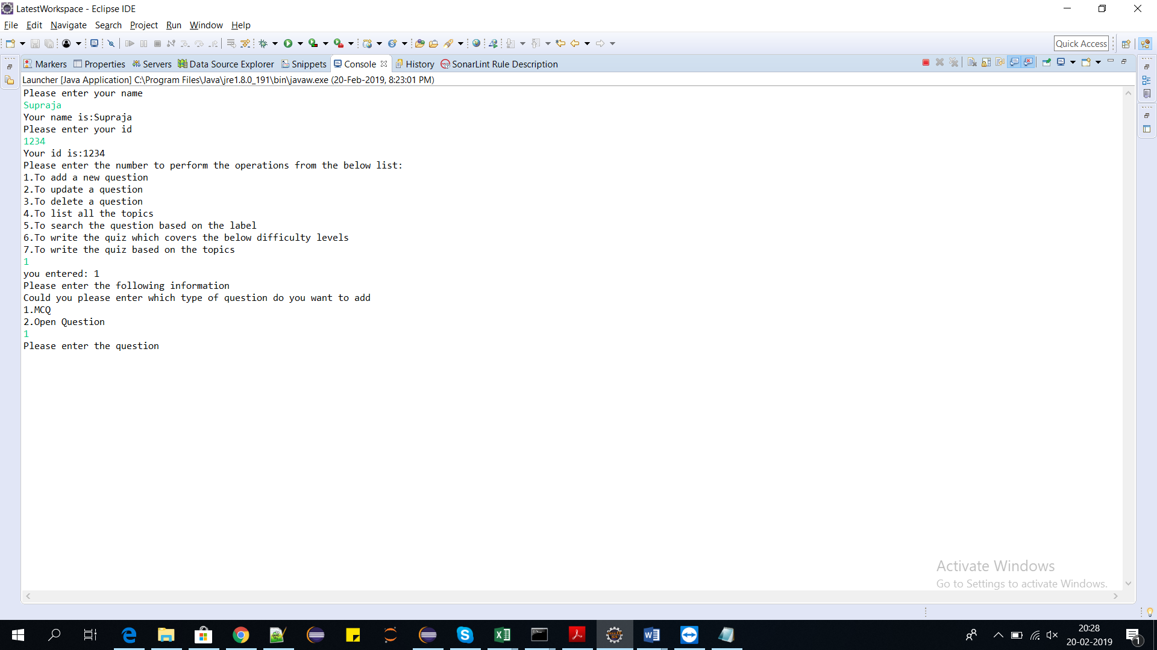

3)The user has to enter the question he wants to create.

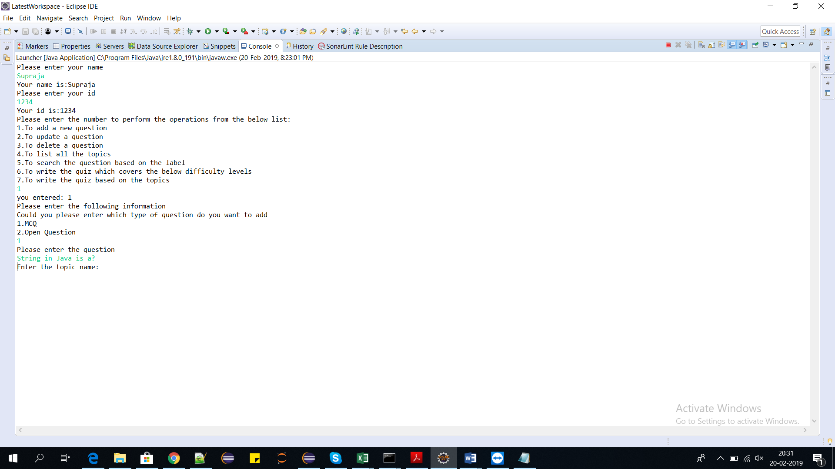

4)The user has to enter the topic name:

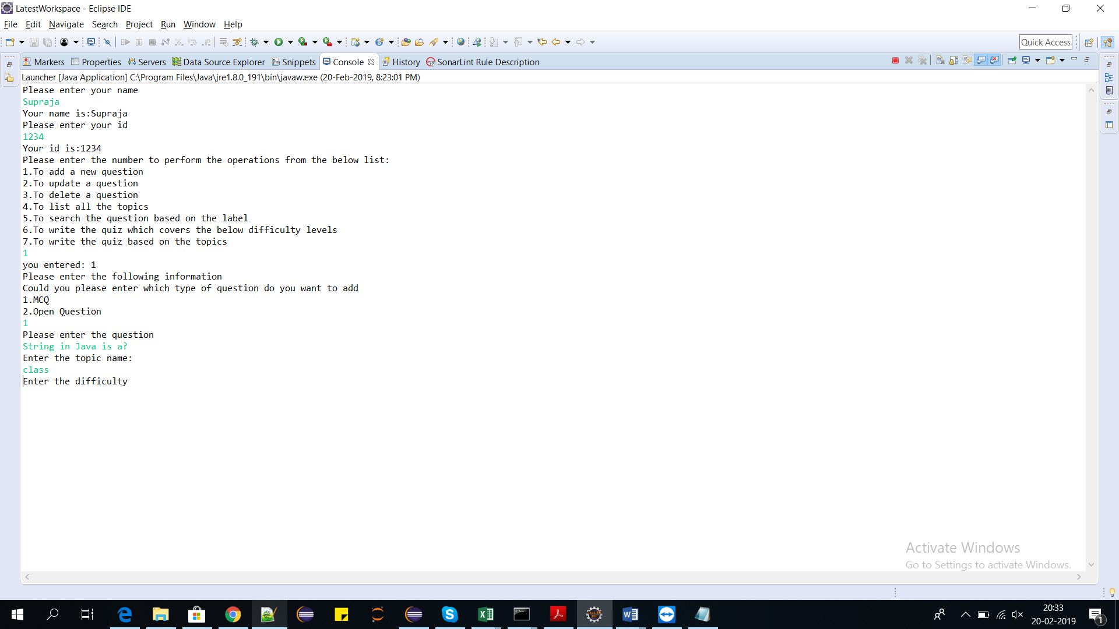

5)The user has to enter the difficulty level

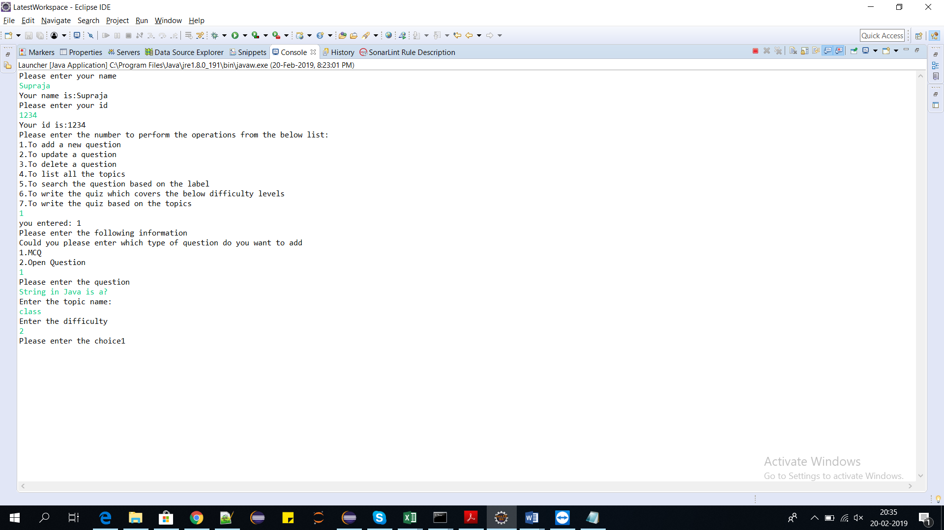

6)The user has to enter the choice1

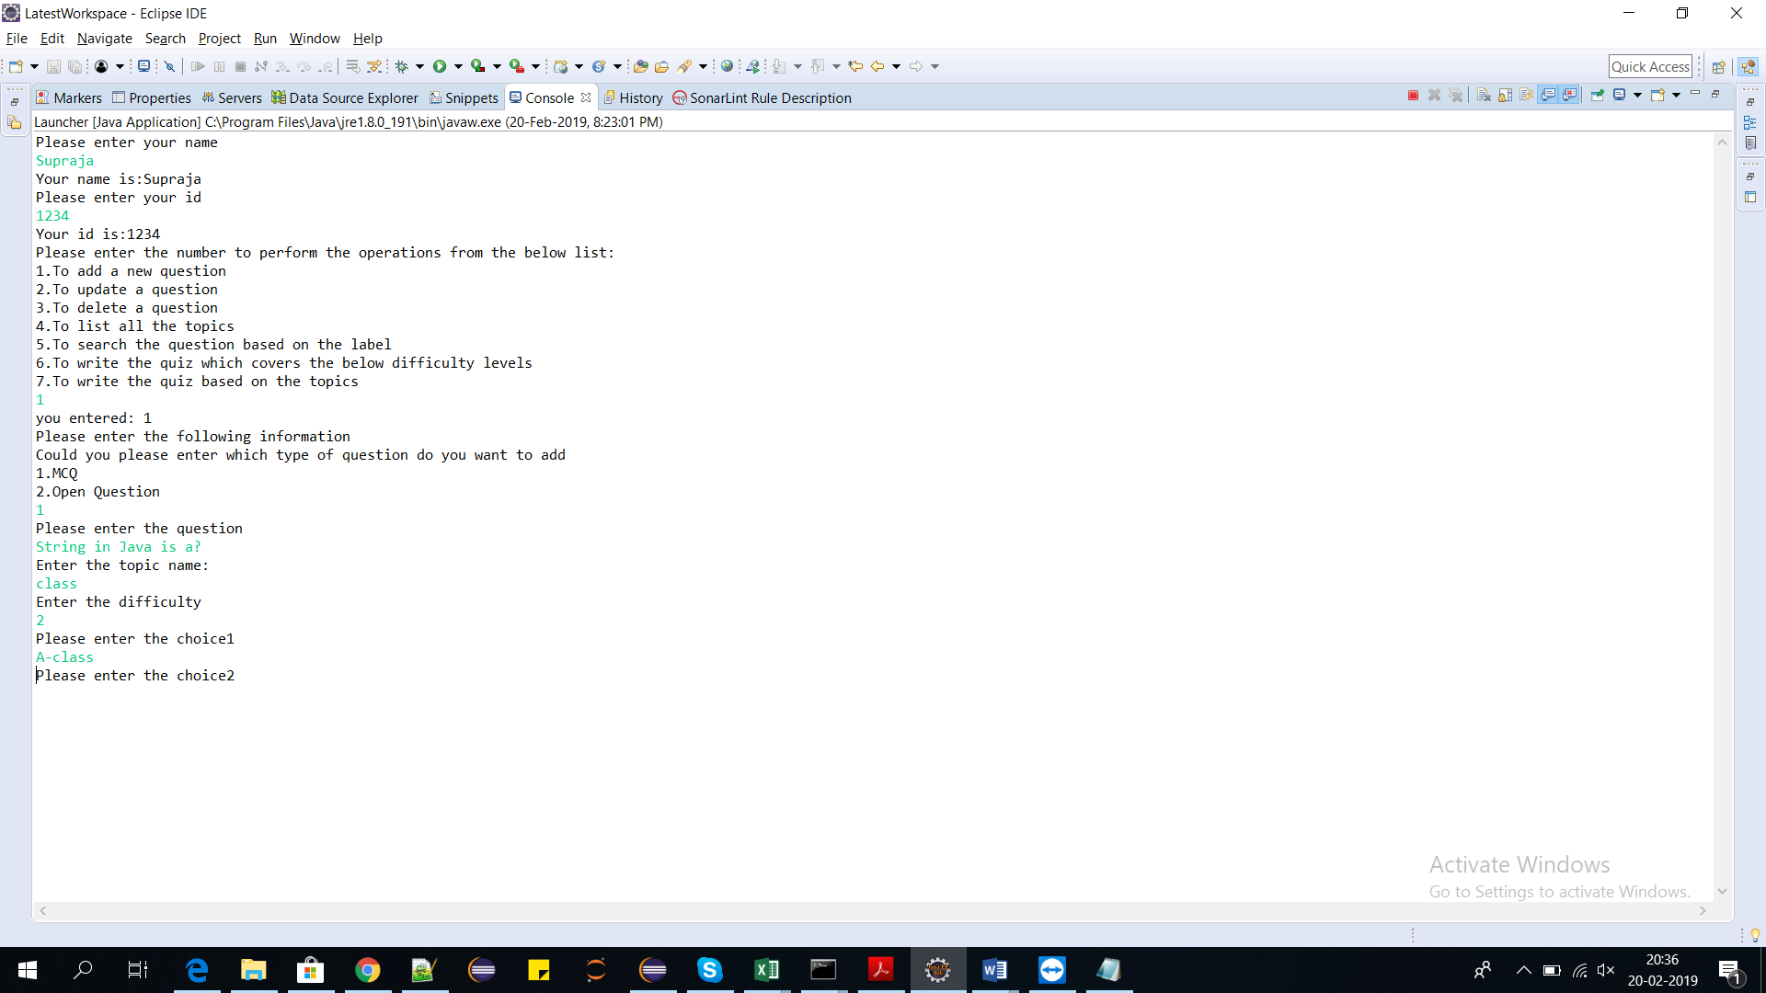

7)The user has to enter the choice2

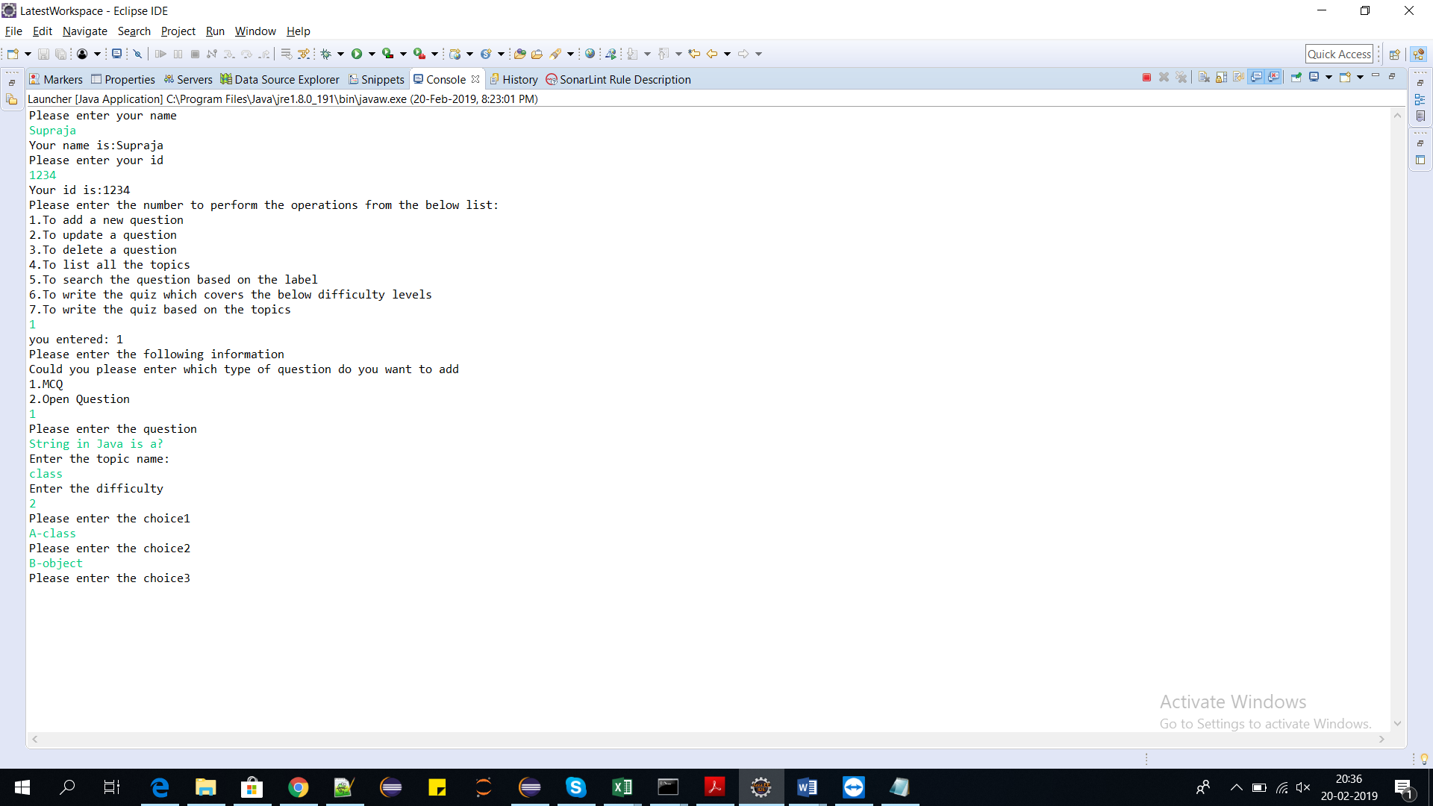

8)The user has to enter the choice3

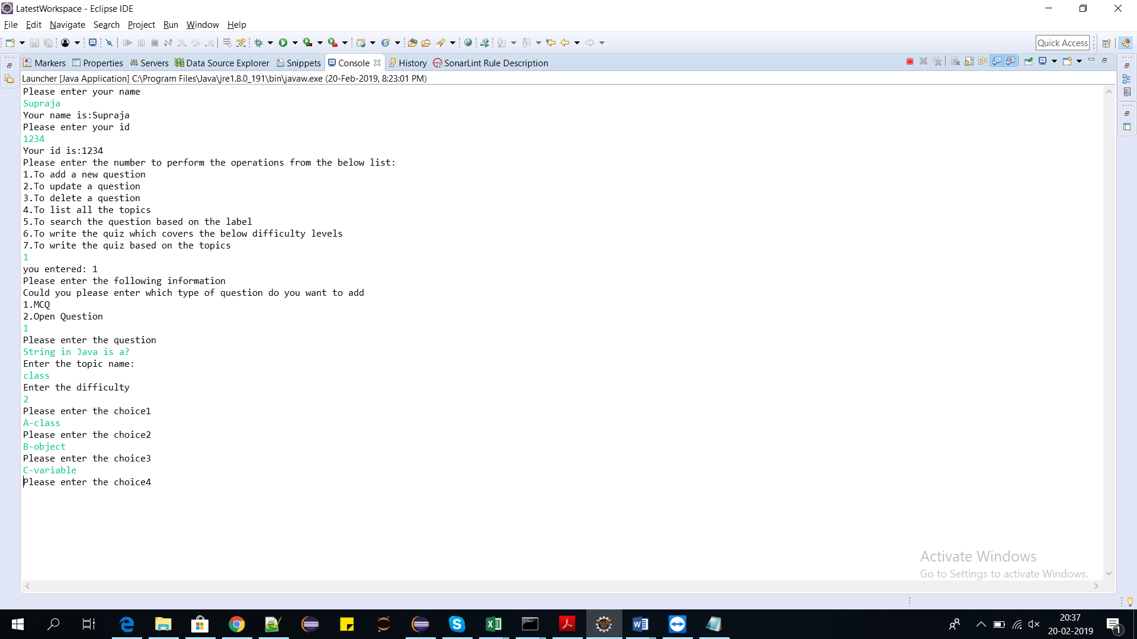

9)The user has to enter the choice4

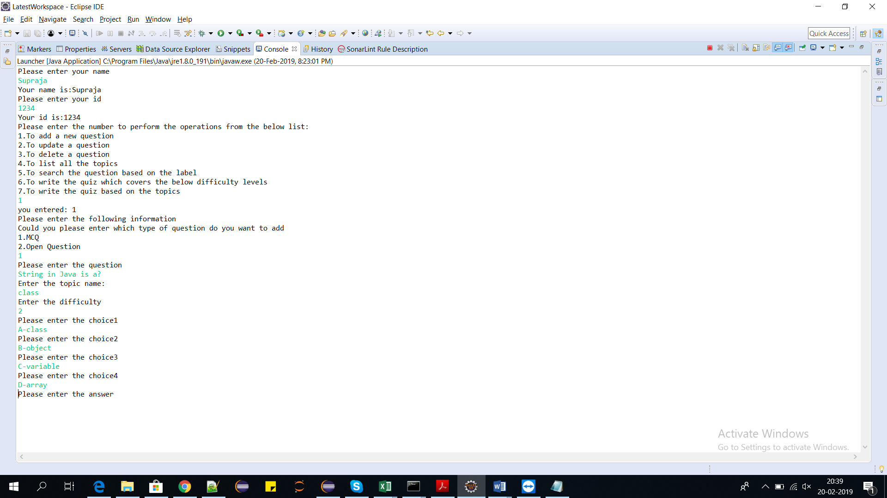

10)The user has to enter the answer

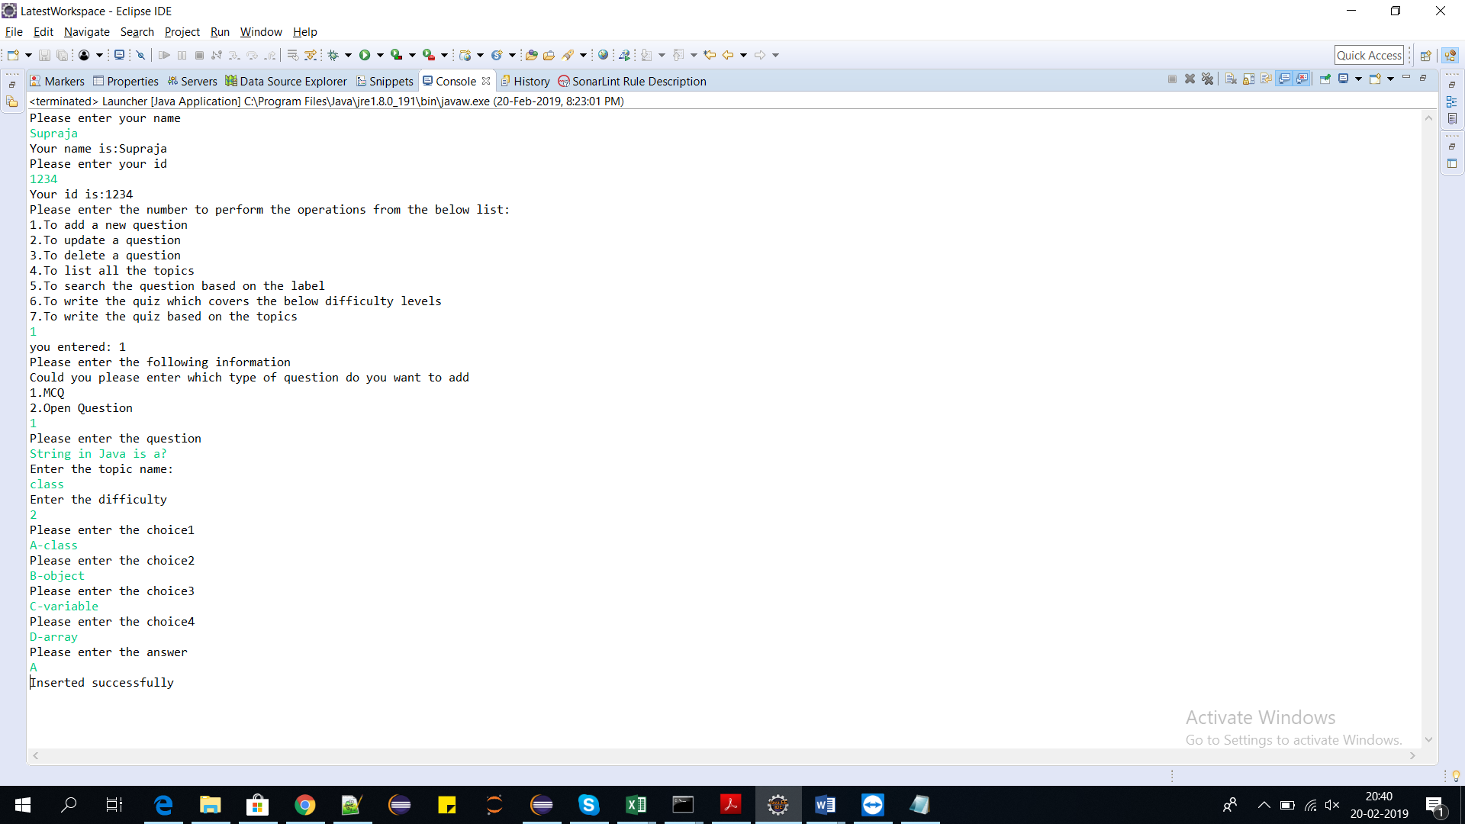

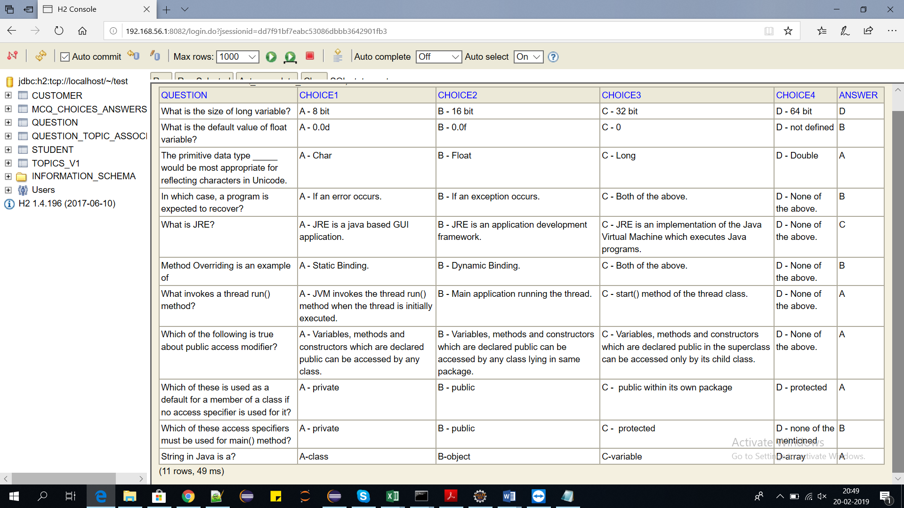

Inserted successfully.

B)1)The user chooses the option 2 to insert open question.

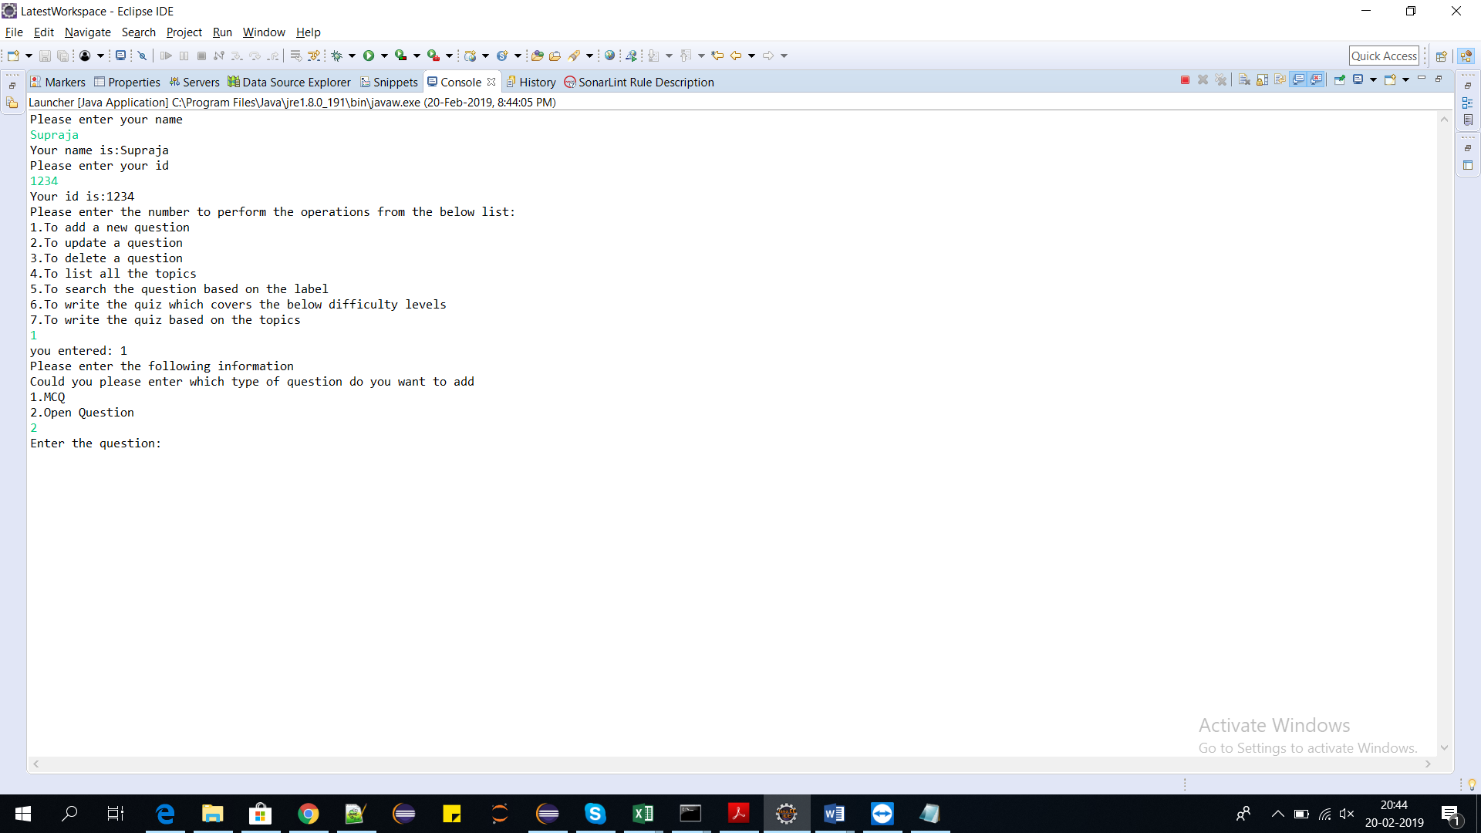

2)The user has to enter the question to be inserted.

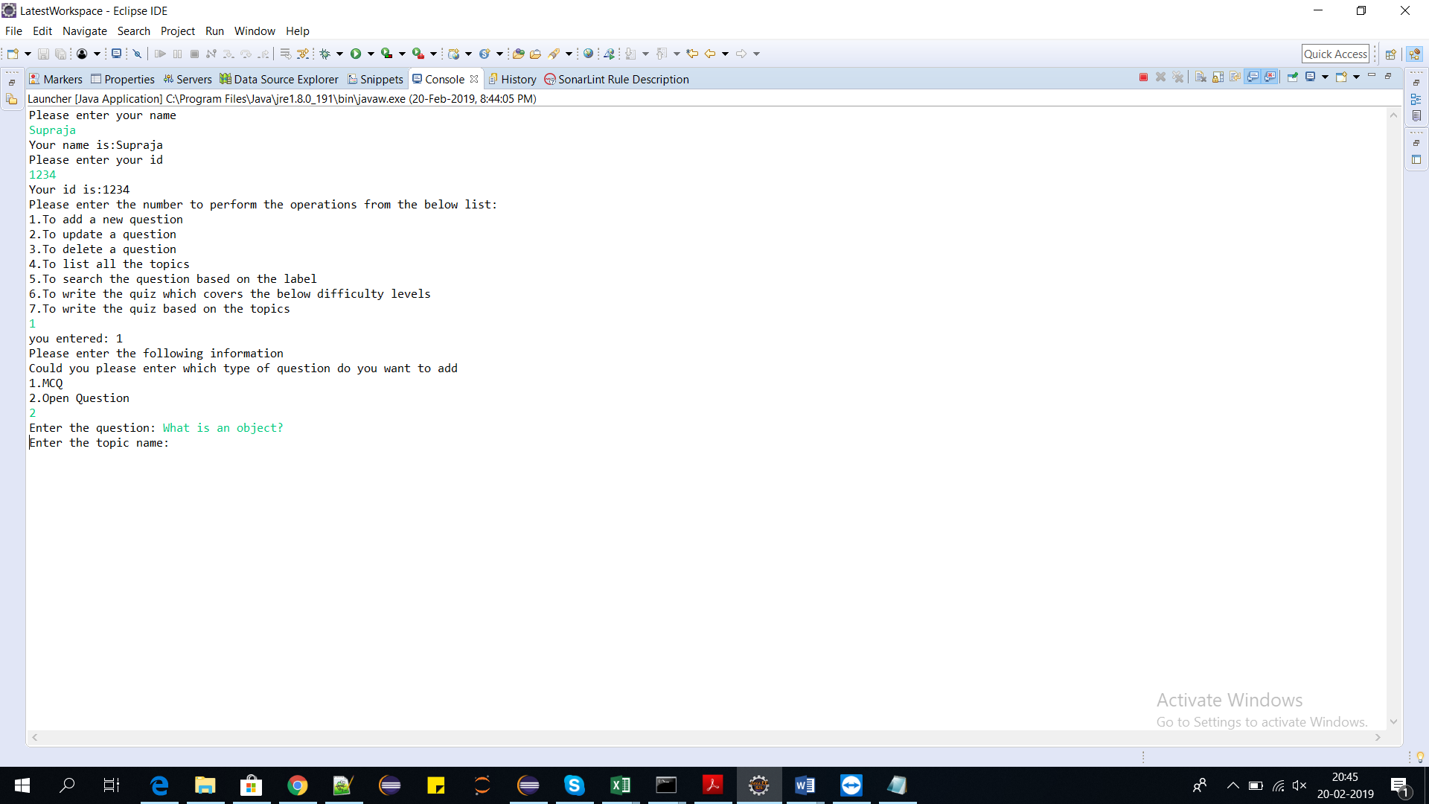

3)The user has to enter the topic name:

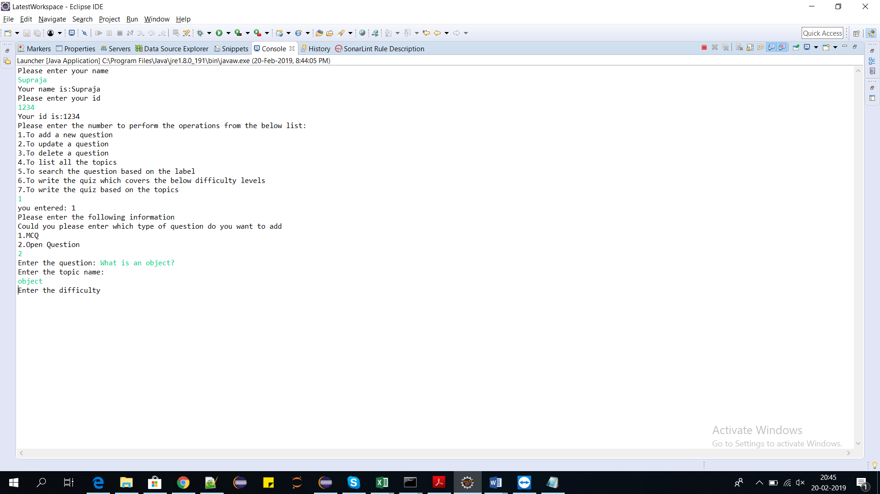

4)The user has to enter the difficulty

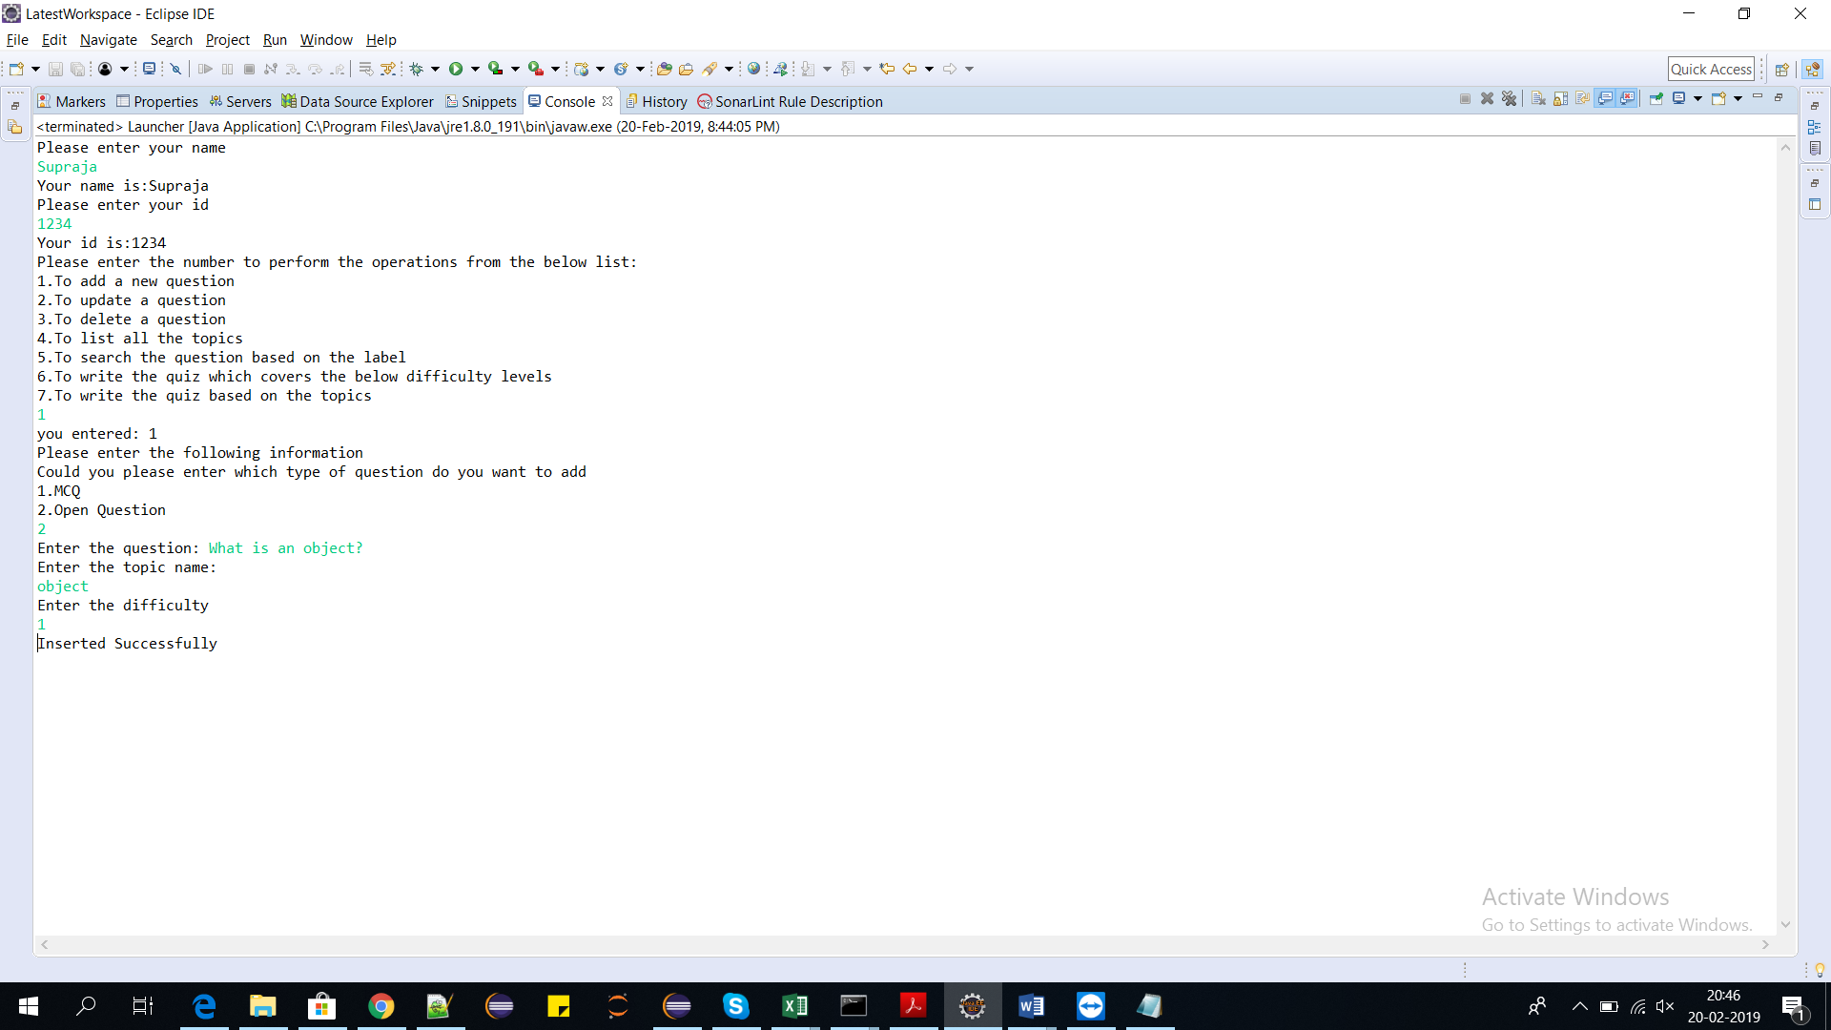

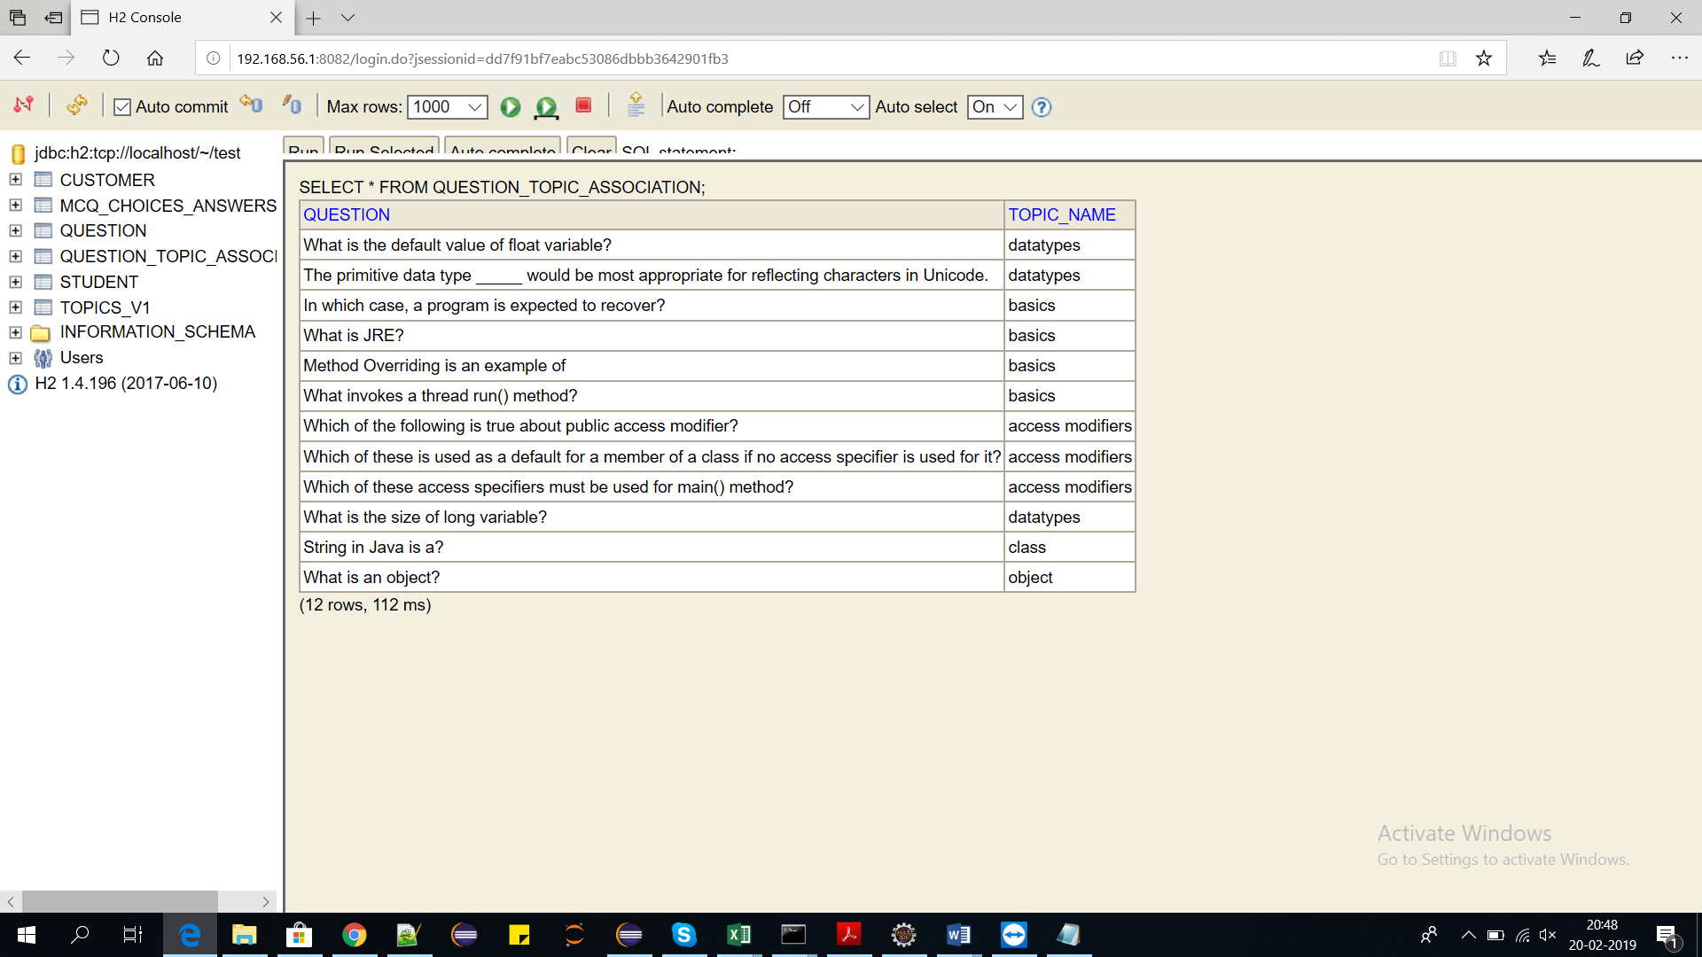

Inserted successfully.

**2)To Update the question:**

1)To update the question the user has to select the option 2 from the below list

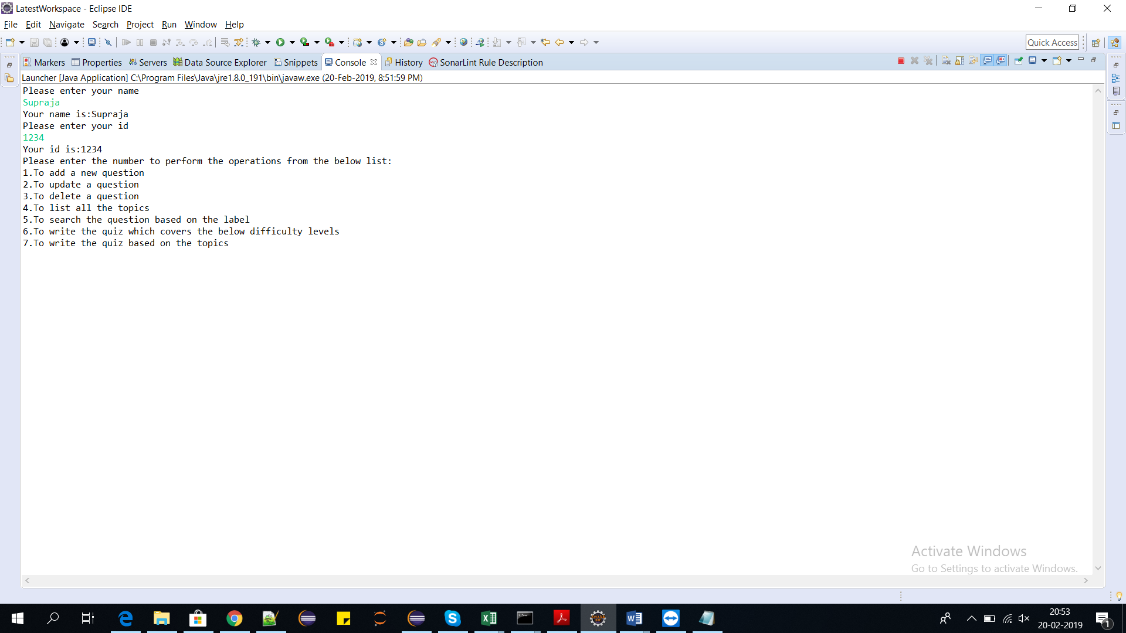

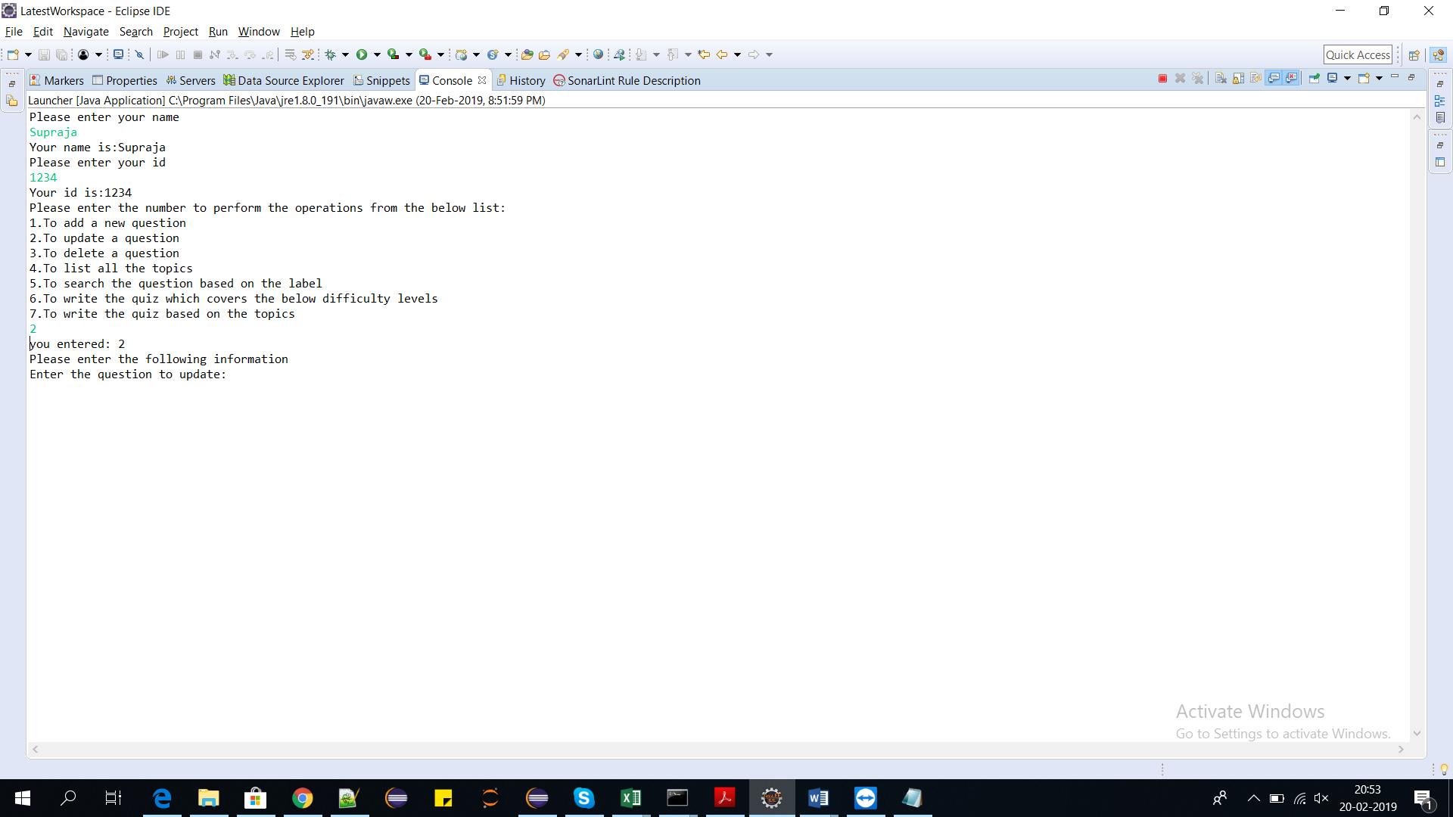

2)The user has to enter the question to be updated

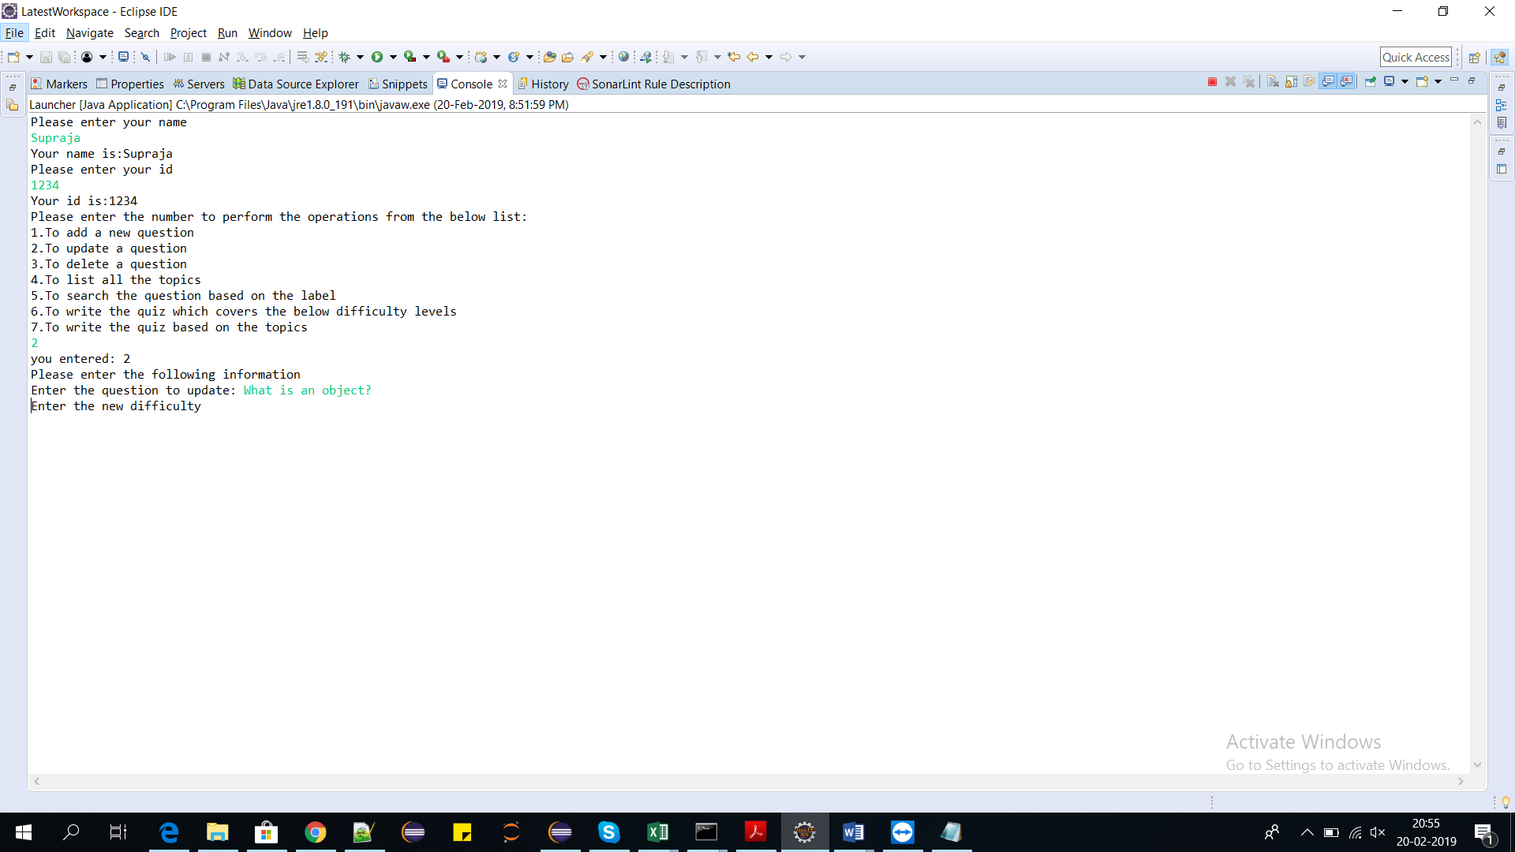

3)The user has to enter the difficulty

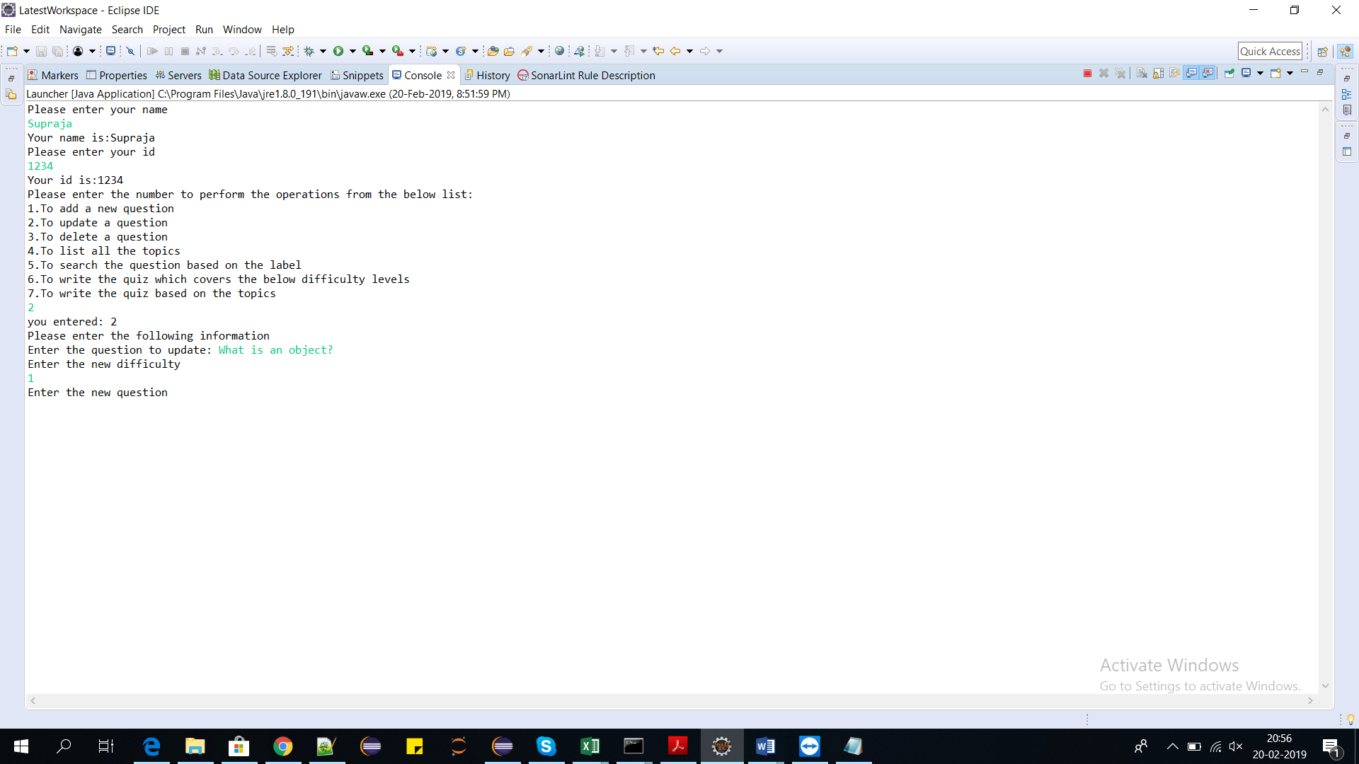

4)The user has to enter the new question

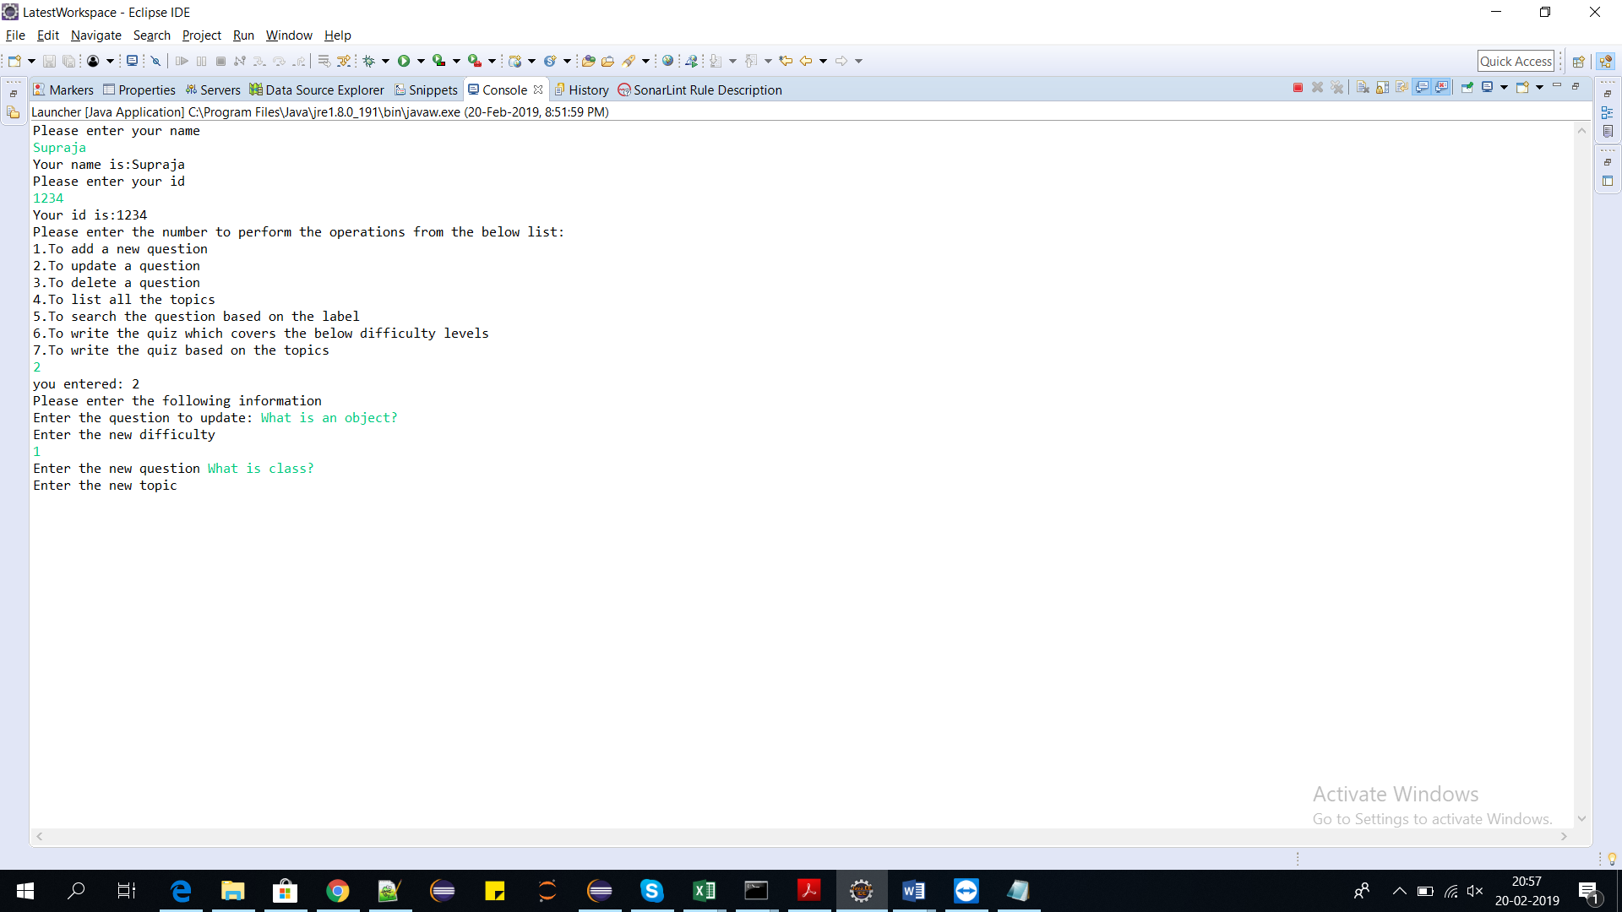

5)The user has to enter the topic name

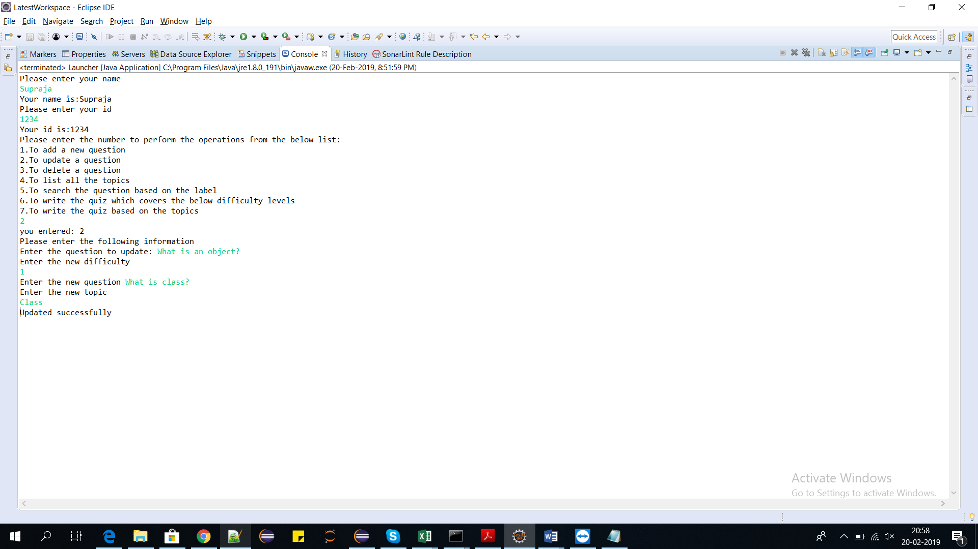

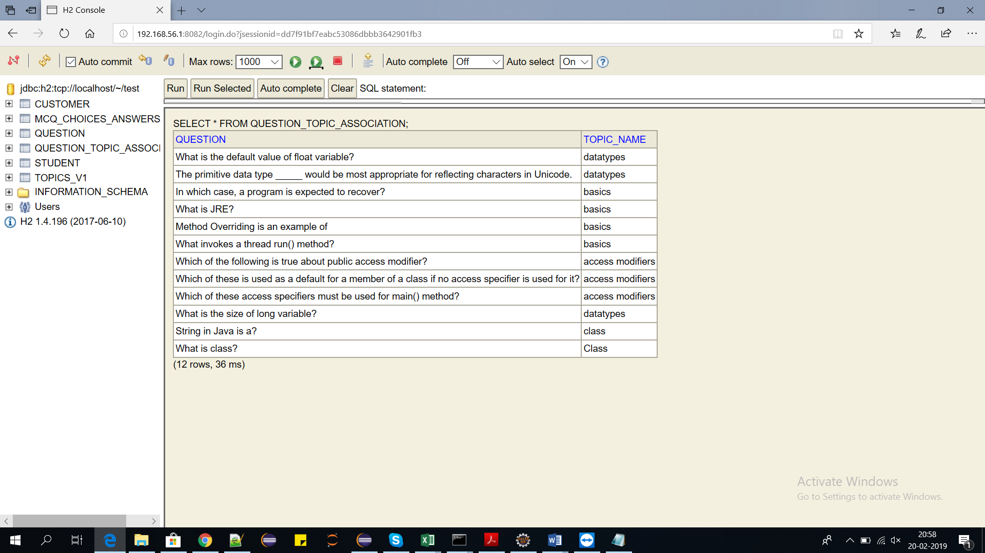

Updated Successfully.

**To delete the question:**

1)To delete the question the user has to enter the option 3 from the below list

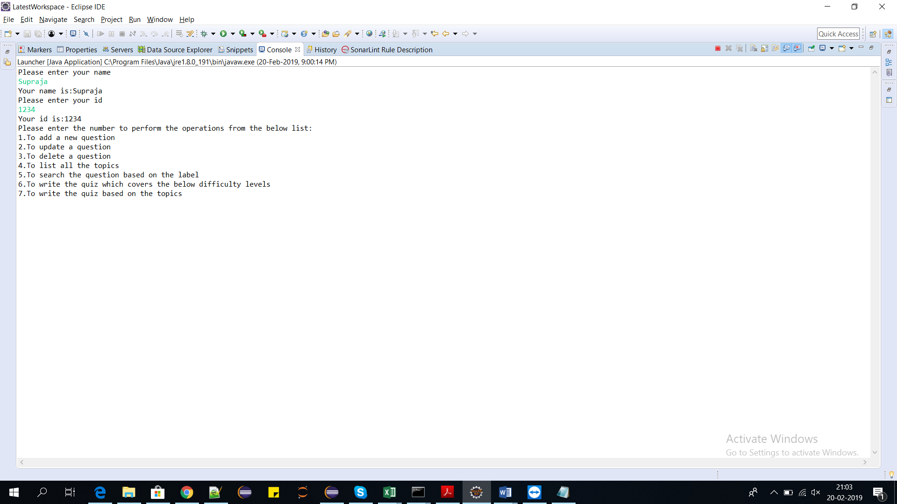

2)Now the user has to enter the question to be deleted

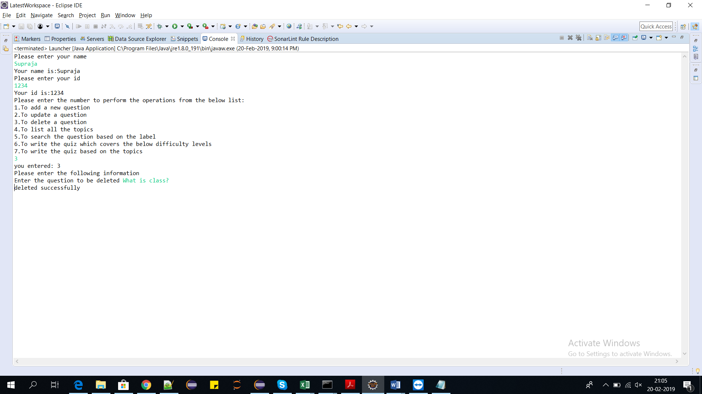

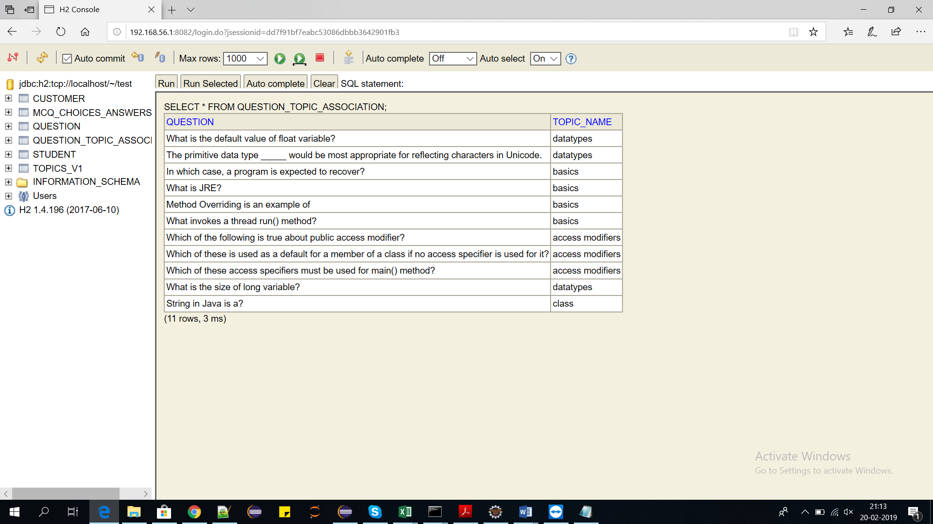

Deleted successfully.

**To list all the topics in the database:**

1)The user has to choose the option 4 from the below list

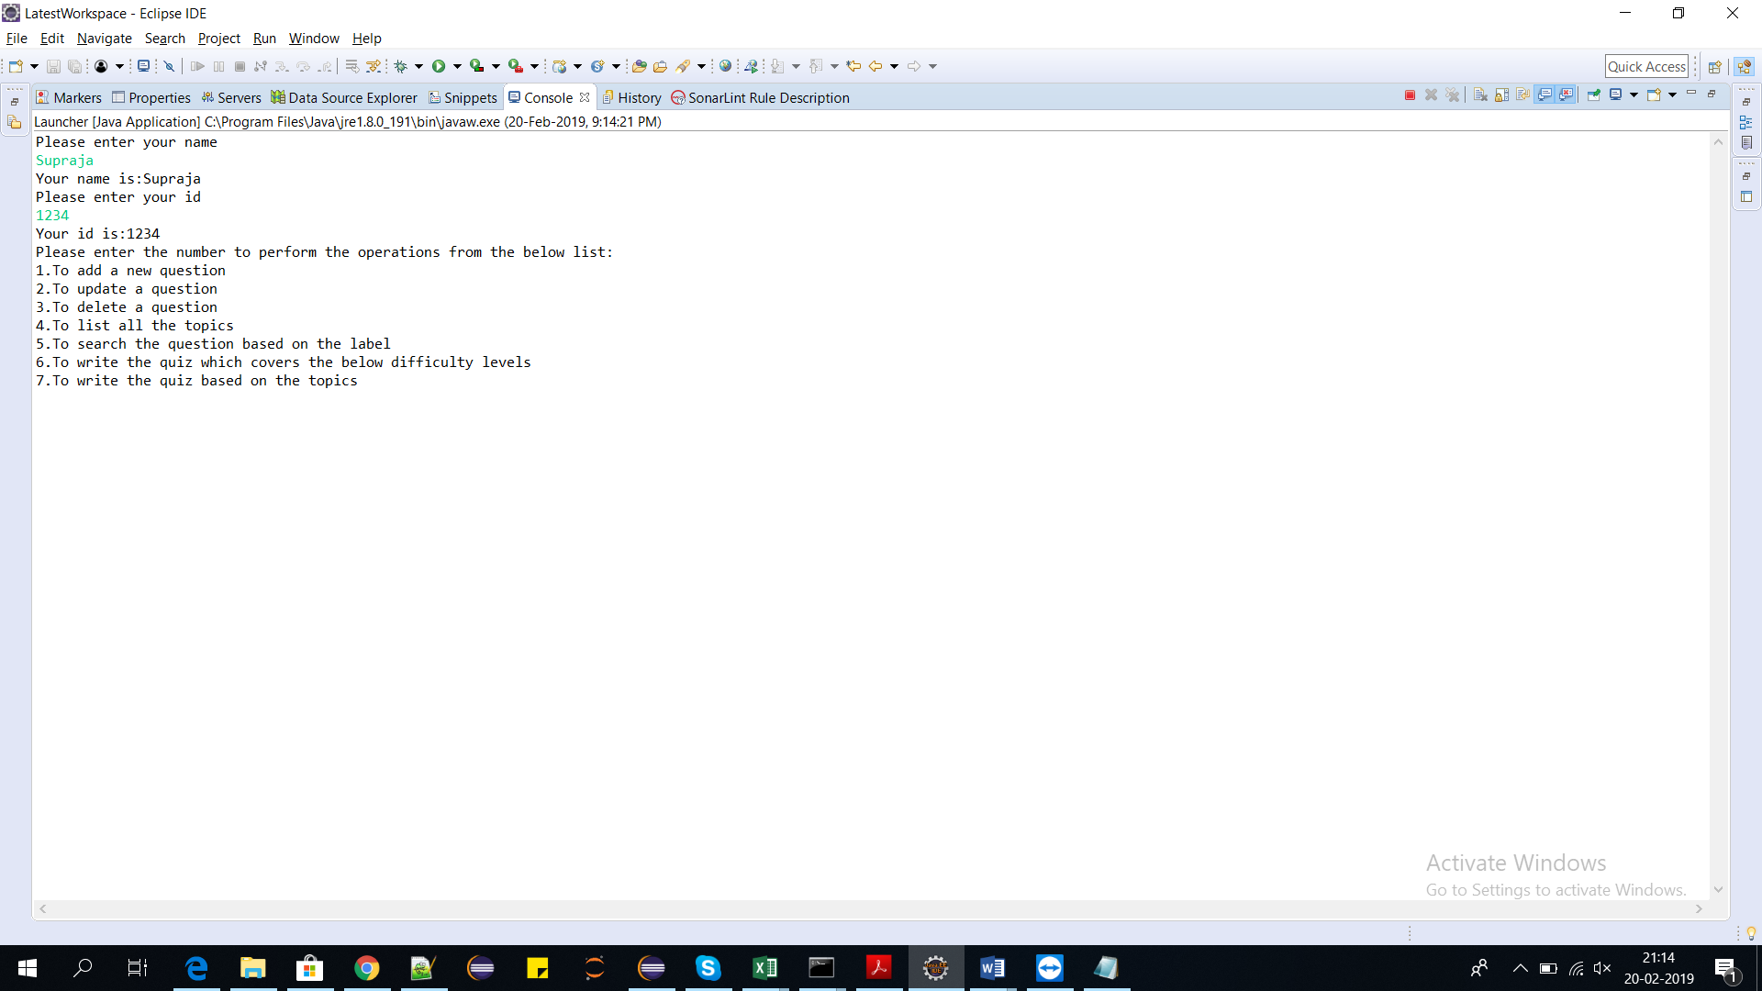

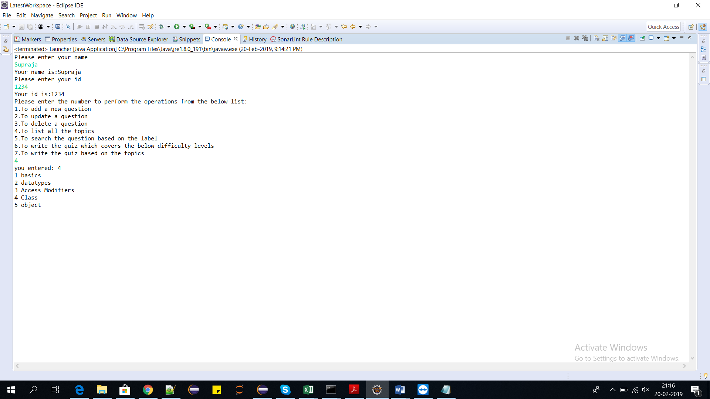

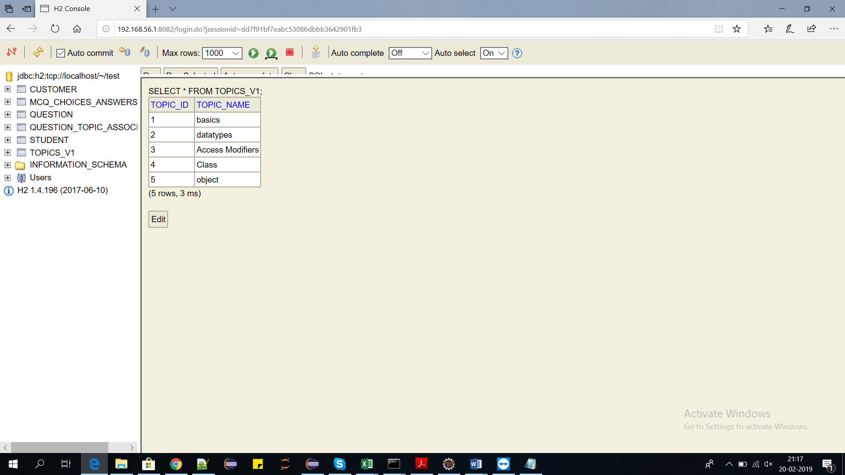

Listed successfully

**To search the question based on the label:**

1)The user has to enter the option 5 to search

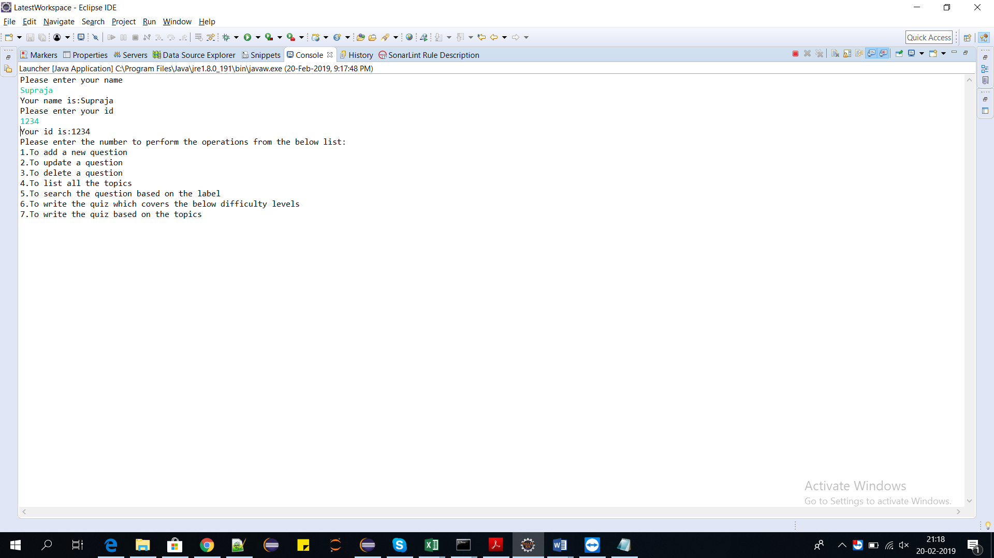

2)The user has to enter the label to search questions

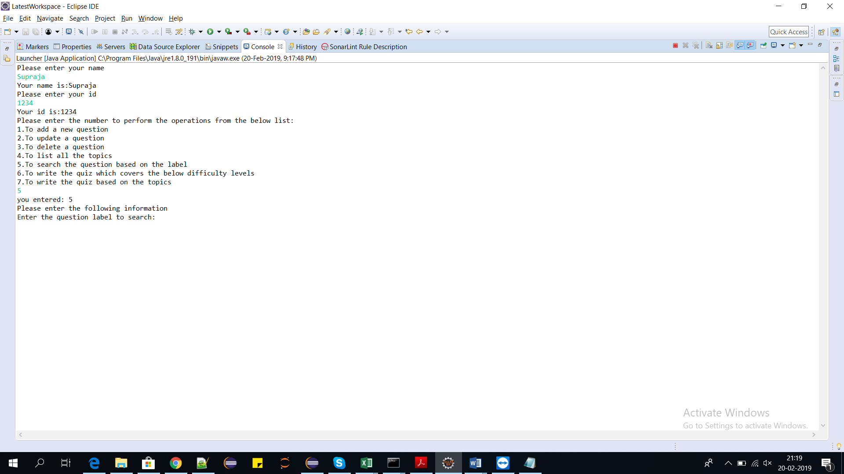

3)The user entered ”What”

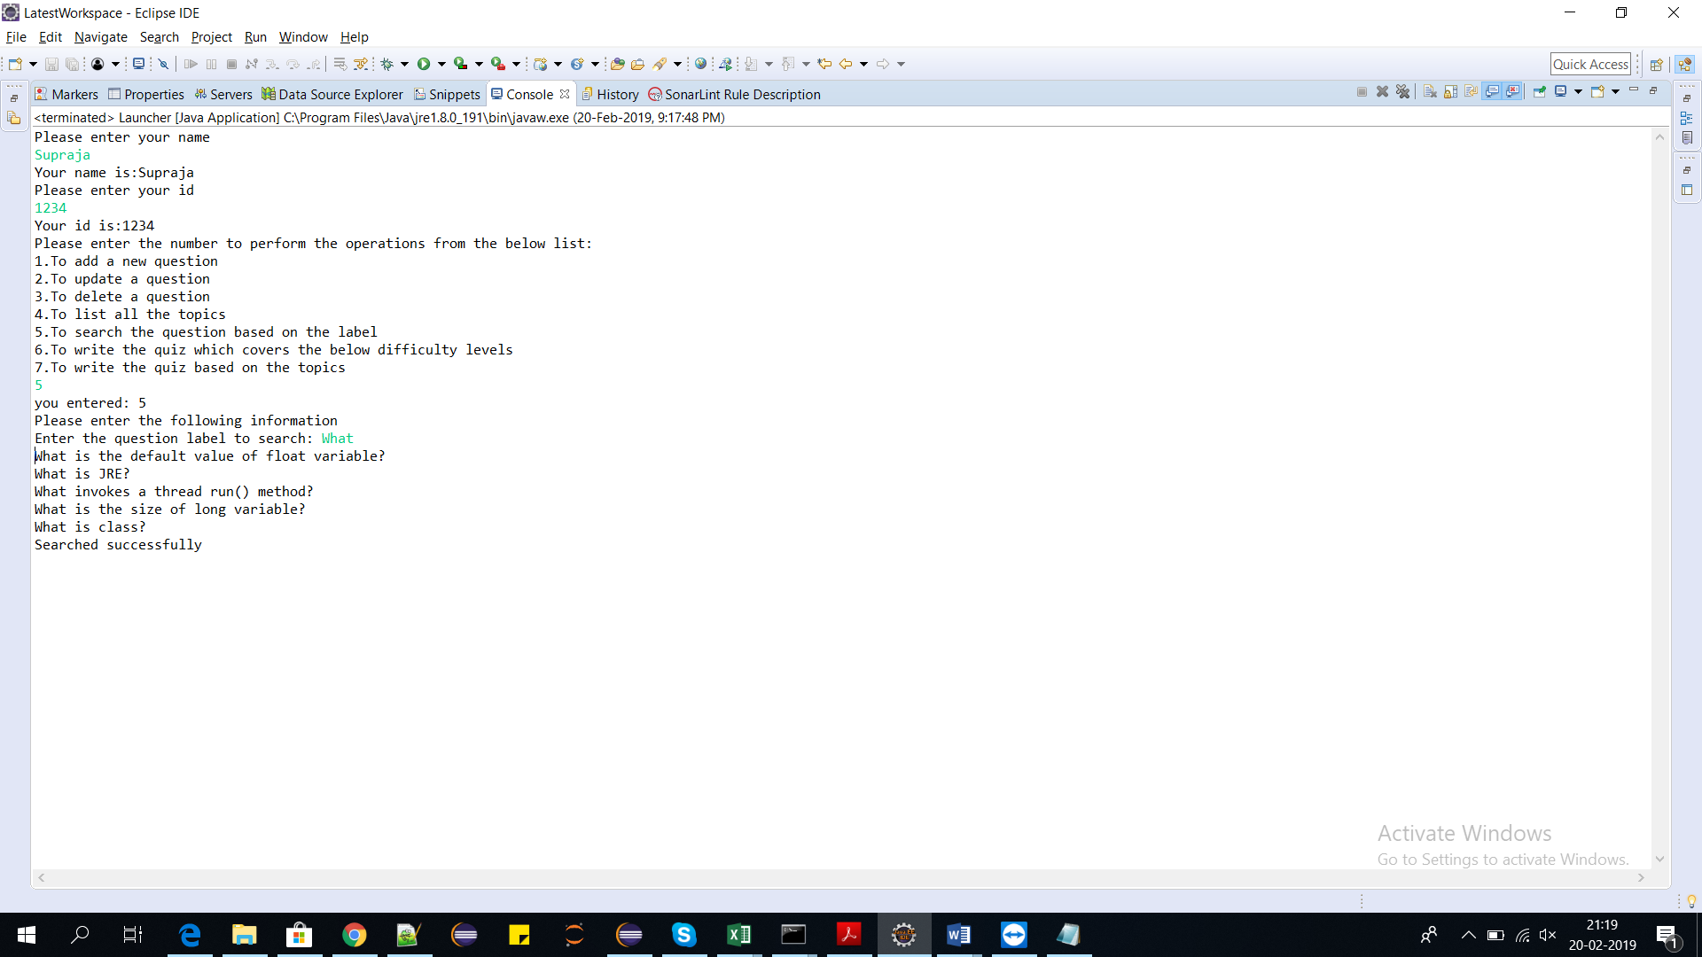

**To get the quiz based on the difficulty level**

1)The user has to enter the option 6 to get the questions based on the difficulty level

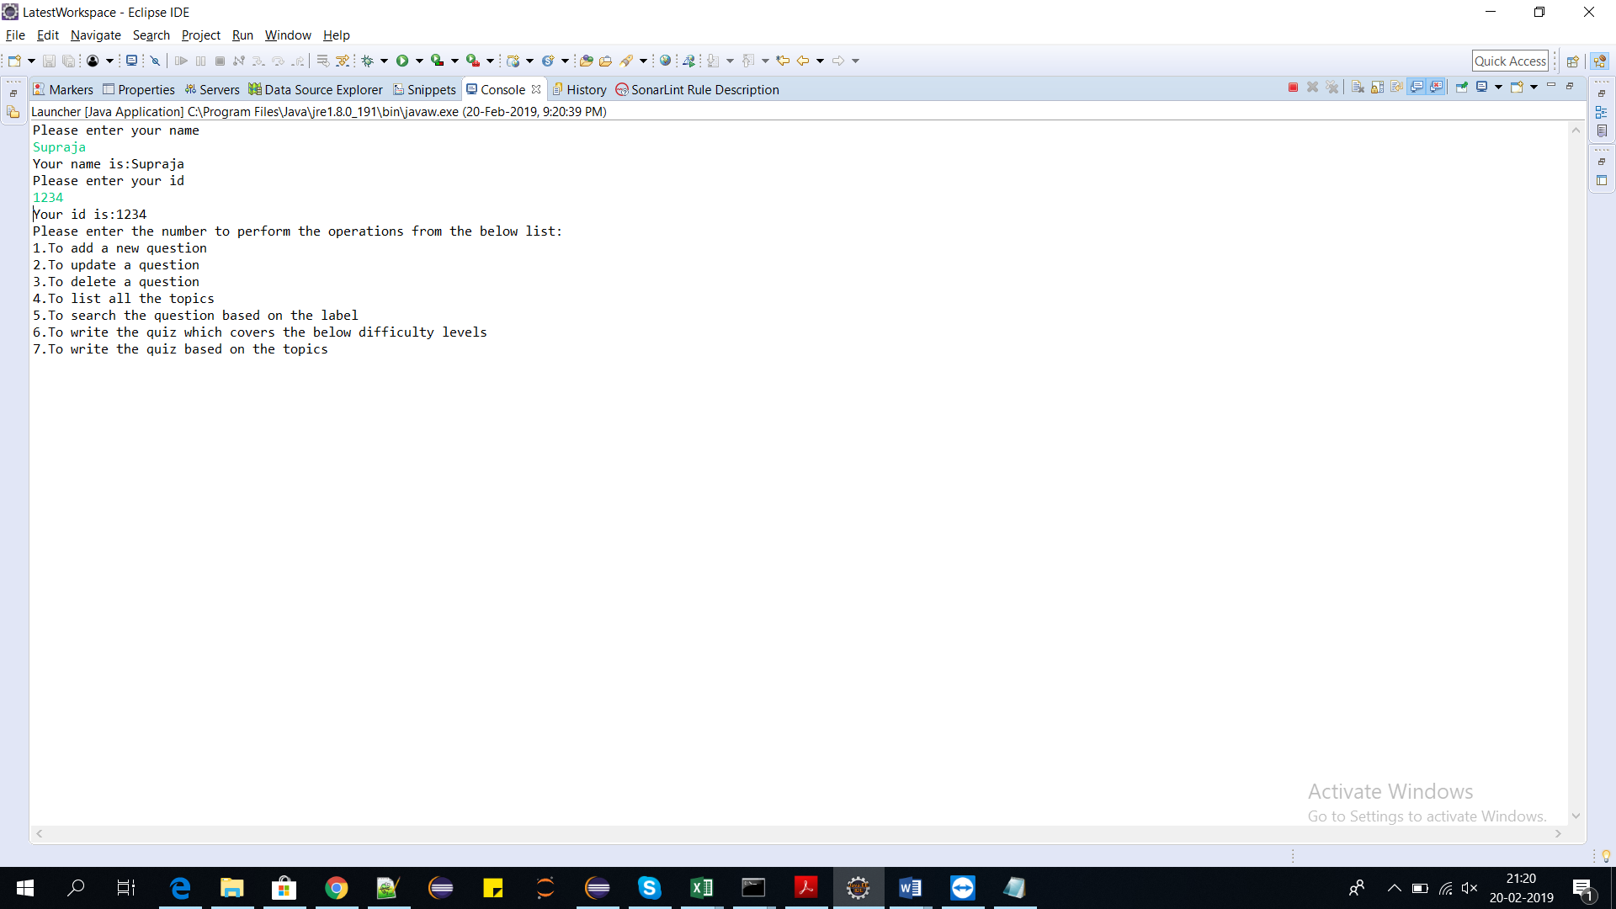

2)The user to enter the difficulty level

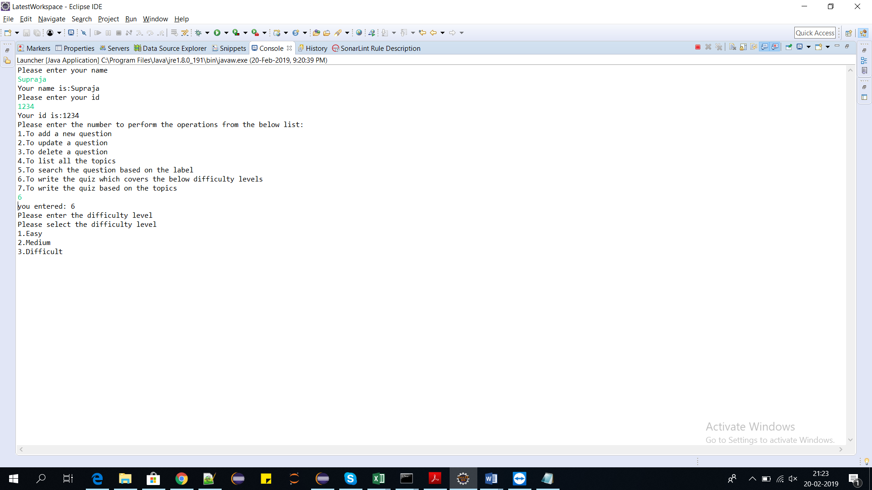

3)The user entered 1

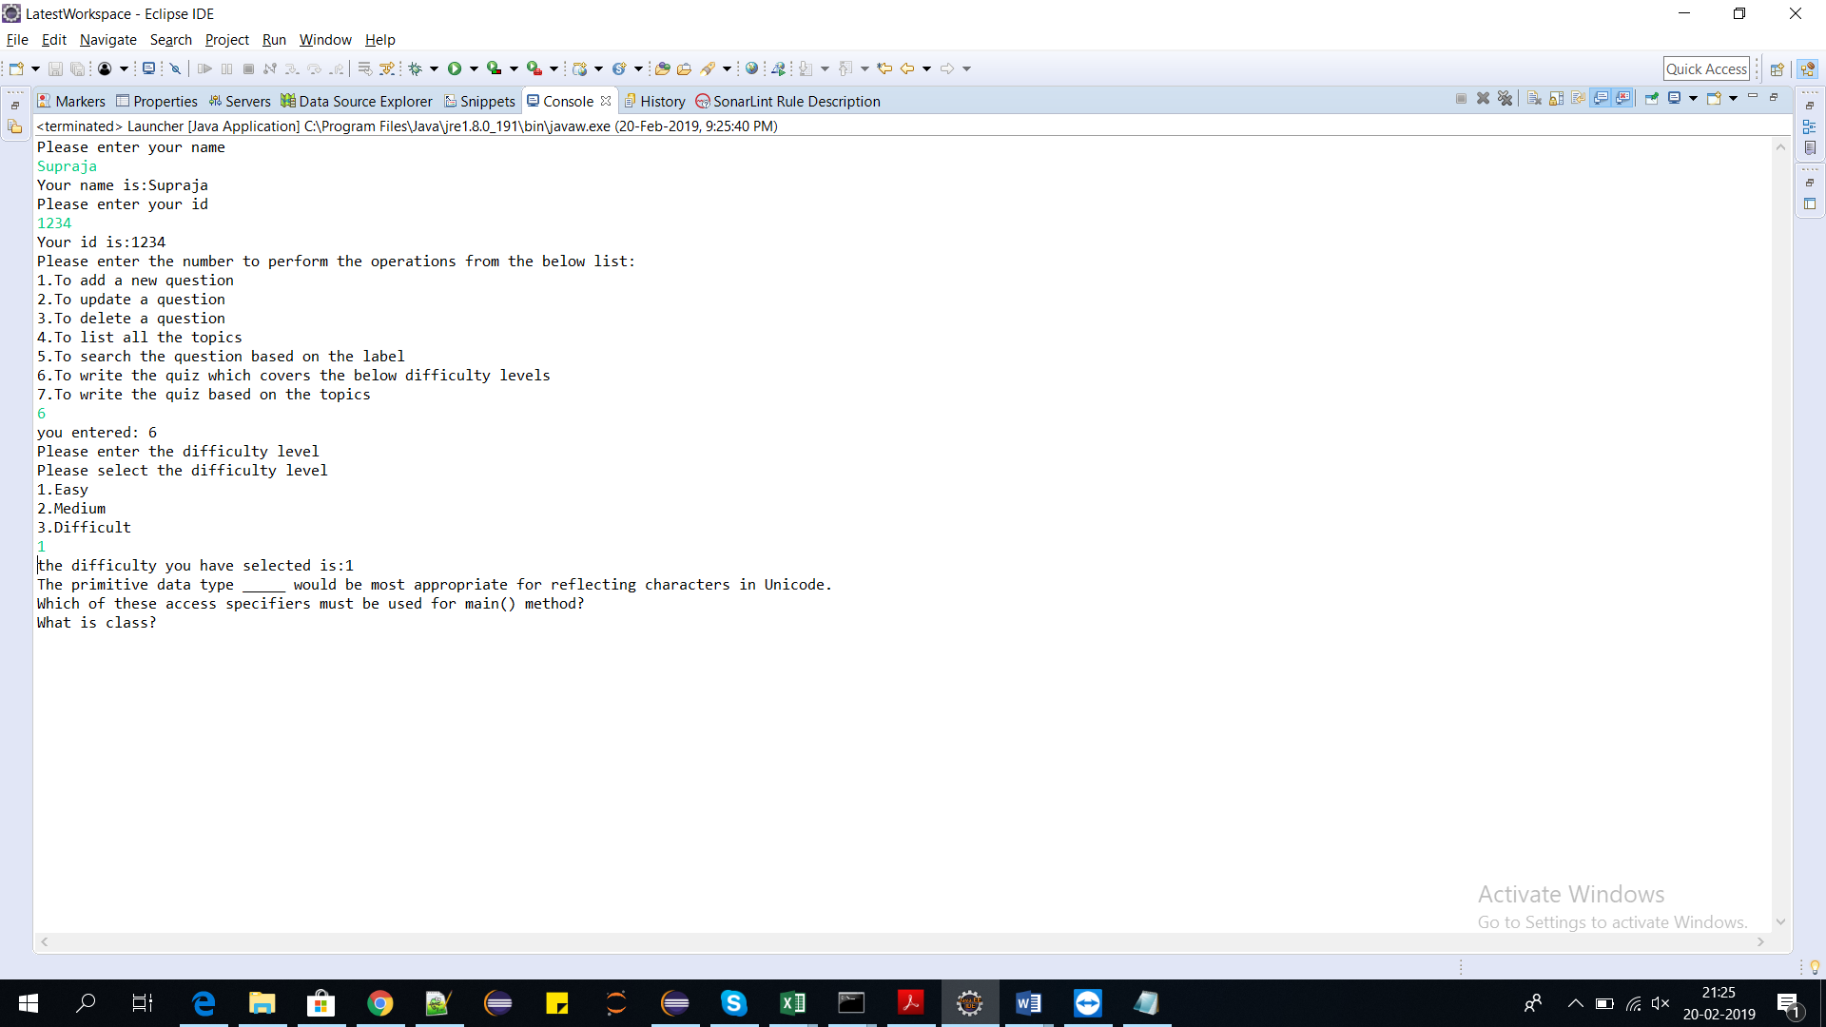

The questions will be automatically loaded in the outputFile of QuestionsBasedOnDifficulty.txt

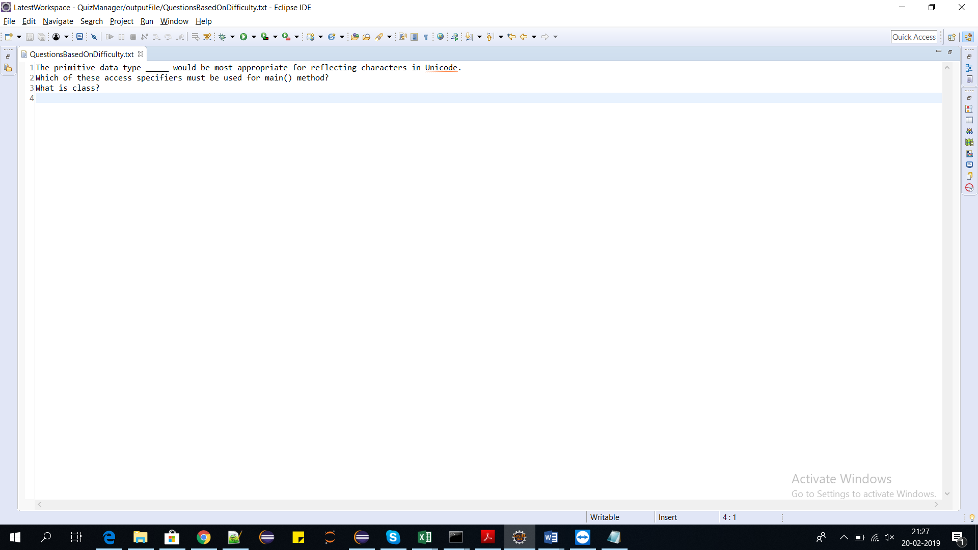

Similarly for Medium and difficult.

**To get questions based on the topic:**

1)To get questions based on the topic the user has to choose the option 7

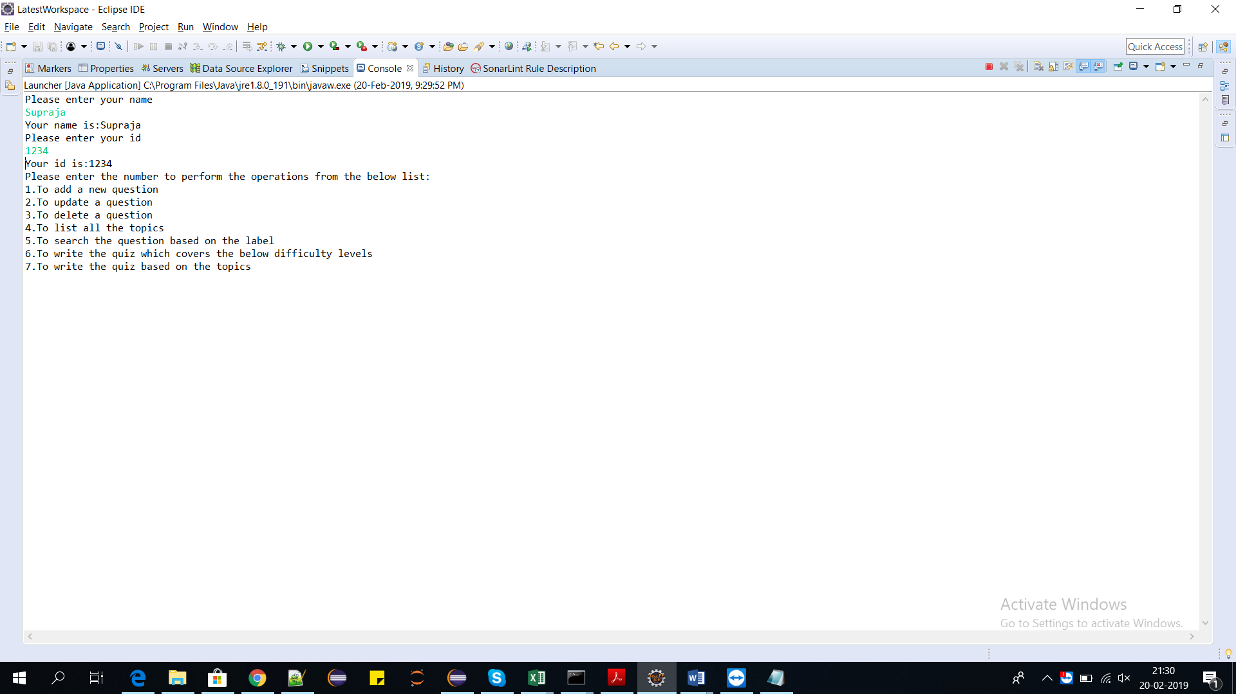

2)The user has to choose the topic from the listed topics. The user entered “basics”

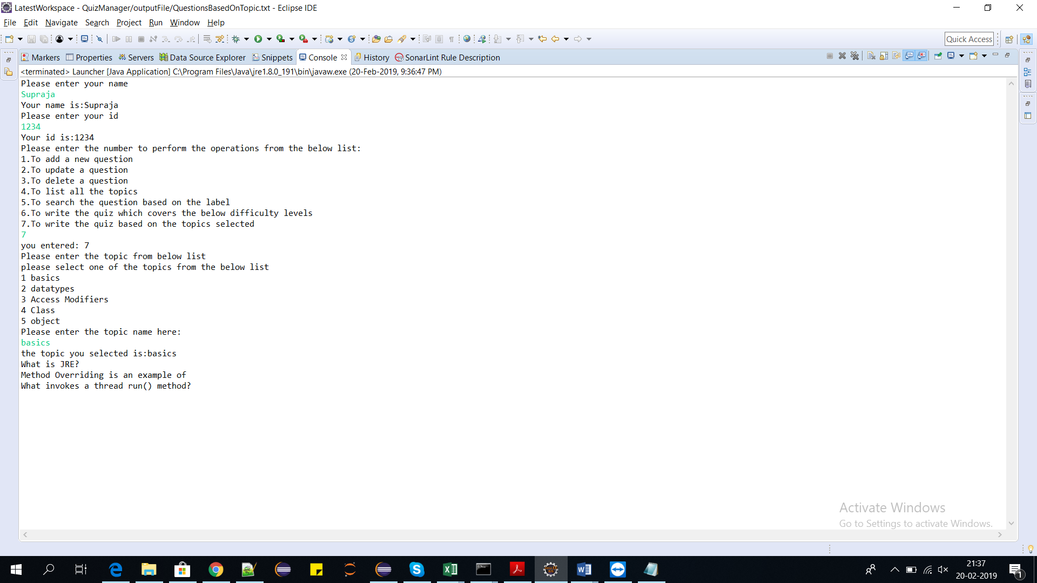

The questions will be automatically loaded in the outputFile folder which is QuestionsBasedOnTopic.txt

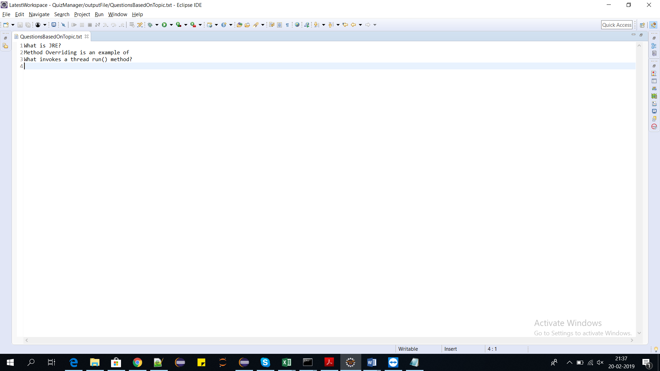

**If the user enters invalid input:**

Here the user entered the option 8. A message is printed on the console to enter the valid input.

